# GyroScope PointOfSale Test Plan

## Test #1 Adding and Customizing VirgoClassicGyro

1. Fire up the application. You should see a window like this:

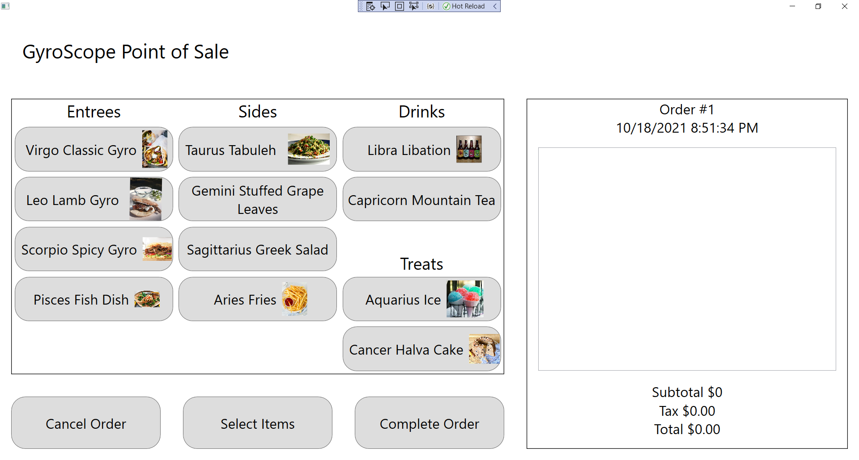

1. Click on Virgo Classic Gyro:

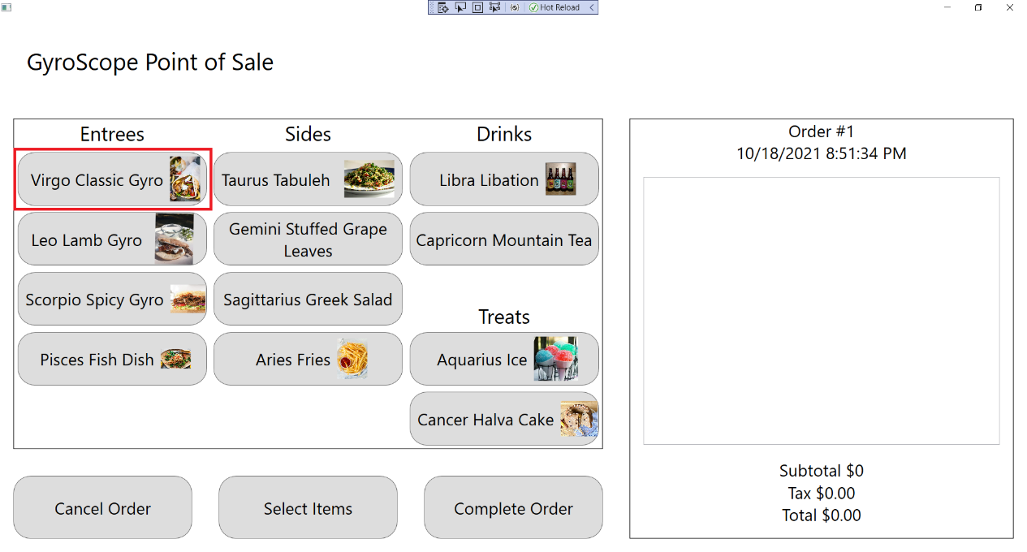

1. The customization screen should appear and a Virgo Classic Gyro should be added to the order, with Order #1, $5.50 Subtotal, $.50 Tax and $6.00 Total being displayed:

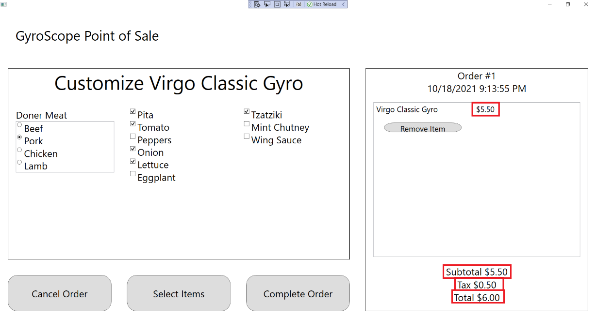

1. Change Doner Meat to Beef, Chicken, or Lamb, and “Use Beef”, “Use Chicken”, or “Use Lamb” should be displayed under the menu item:

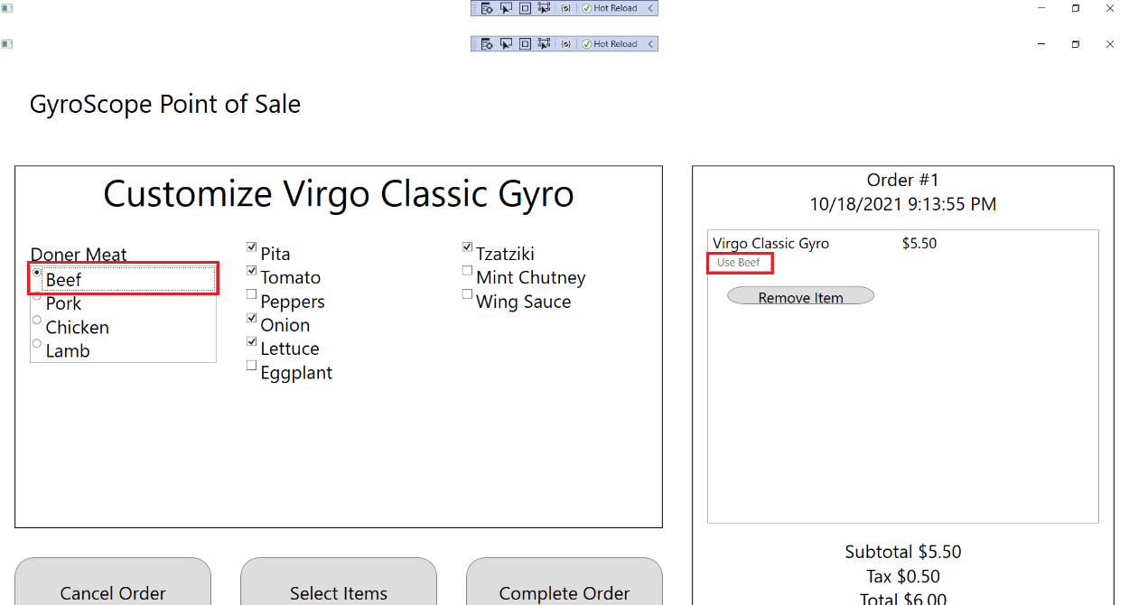

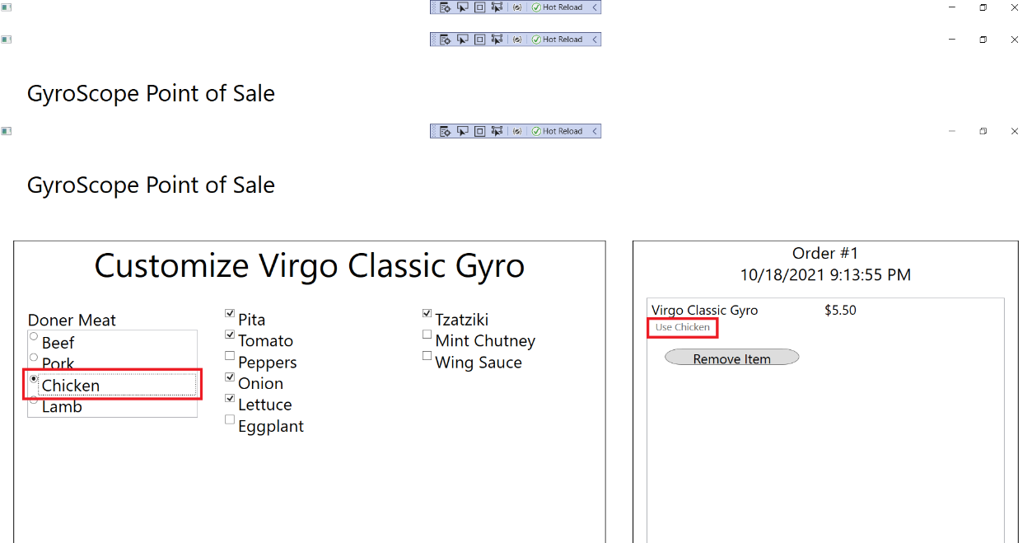

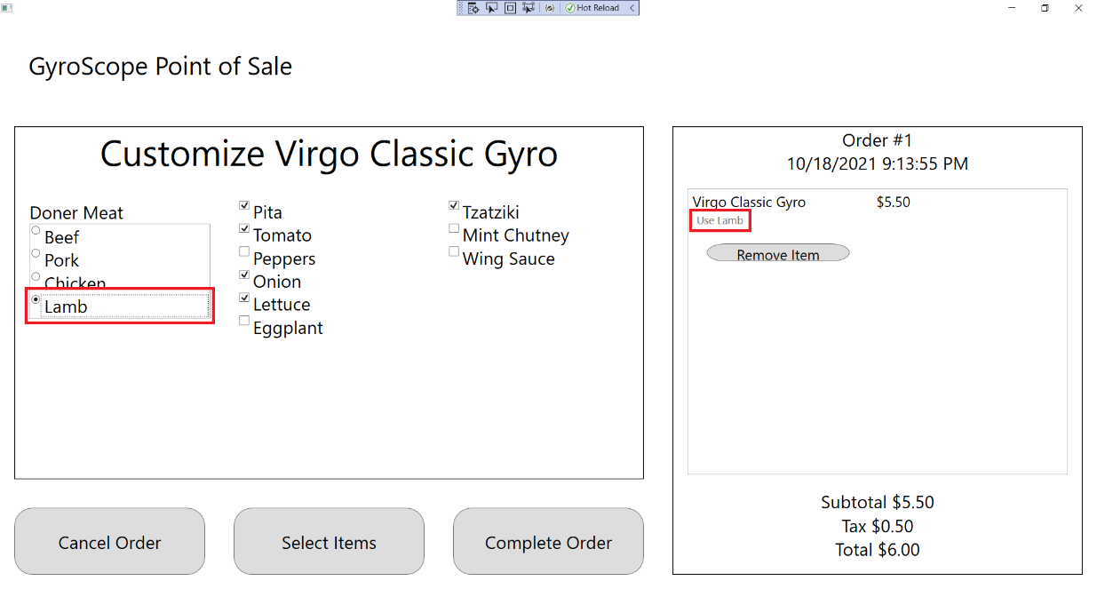

1. Uncheck Pita, Tomato, Onion, Lettuce, and Tzatziki. All unchecked items should show up underneath the menu item as “hold [item]”:

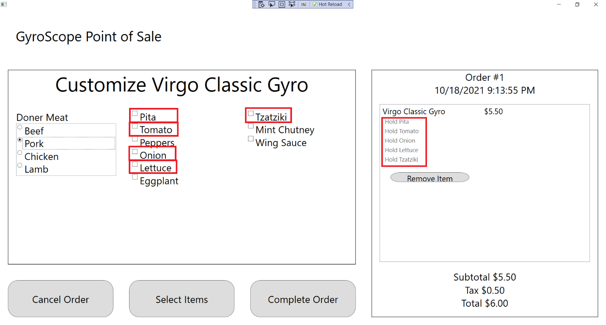

1. Check all boxes. All added items should show up underneath the menu item as “Add [item]”

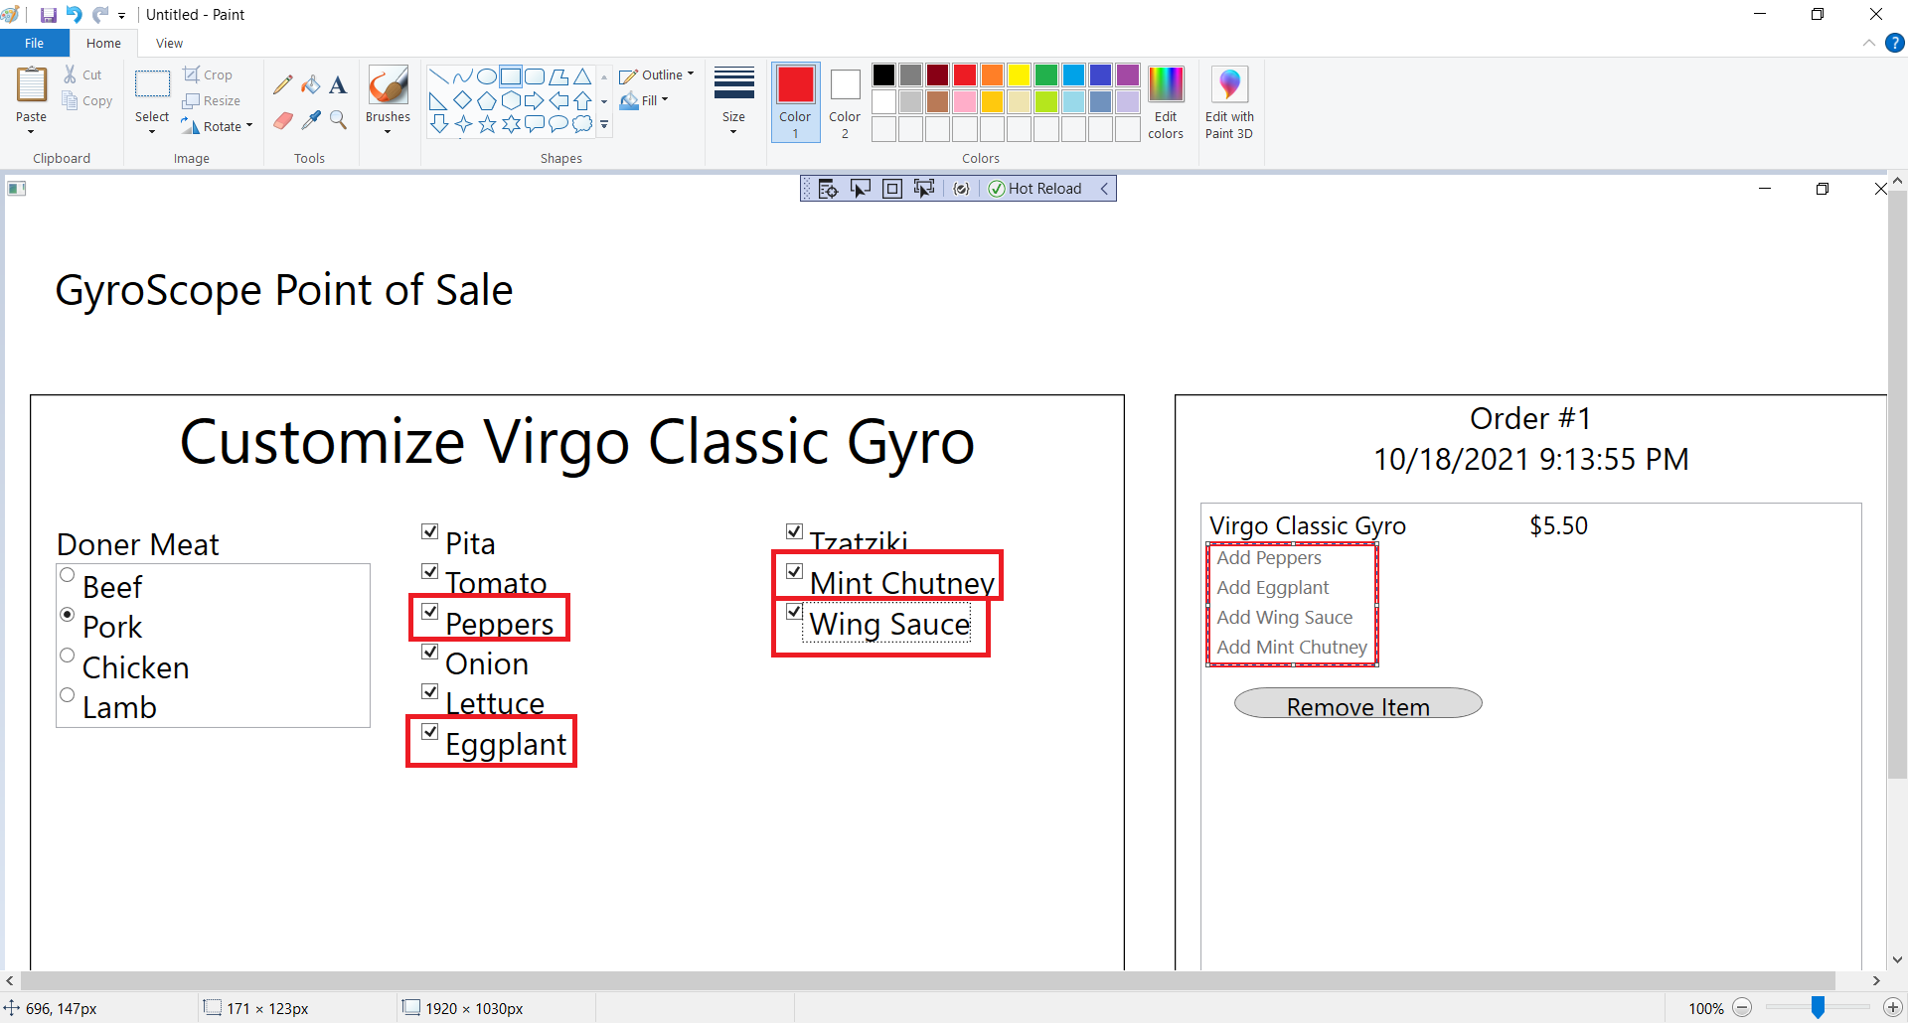

## Test #2 Adding and Customizing LeoLambGyro

1. Click on Leo Lamb Gyro:

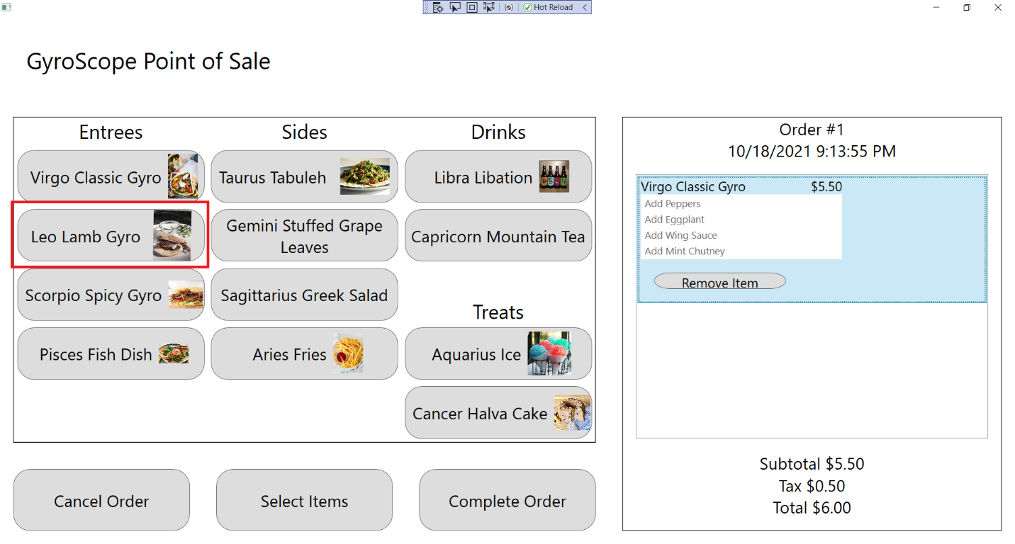

1. The customization screen should appear and a Leo Lamb Gyro should be added to the order, with Order #1, $5.75 Subtotal, $.52 Tax and $6.27 Total being displayed:

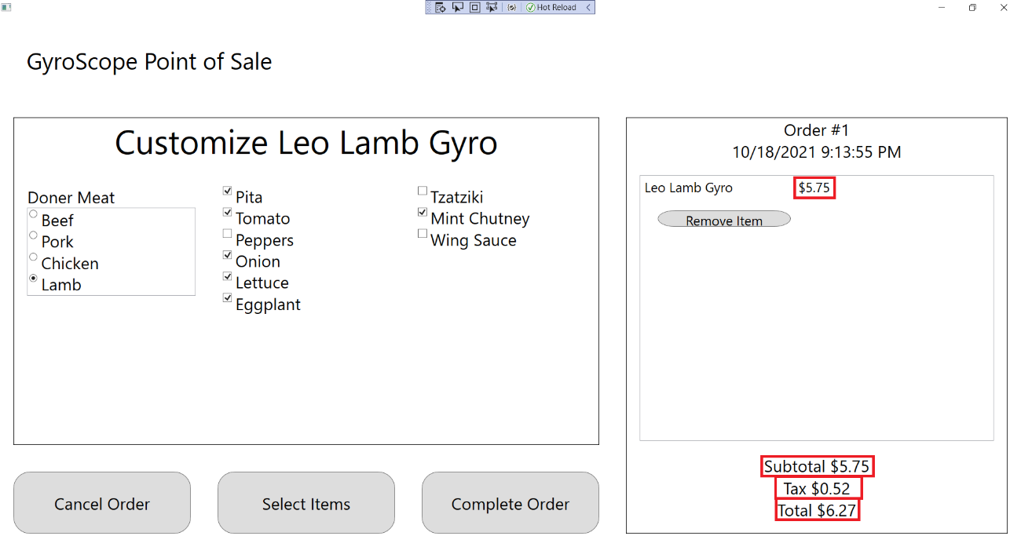

1. Change Doner Meat to Beef, Chicken, or Pork, and “Use Beef”, “Use Chicken”, or “Use Pork” should be displayed under the menu item:

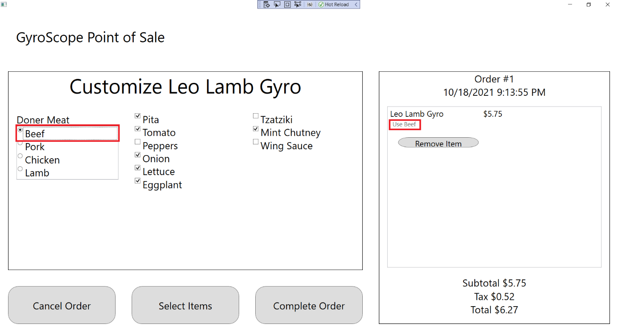

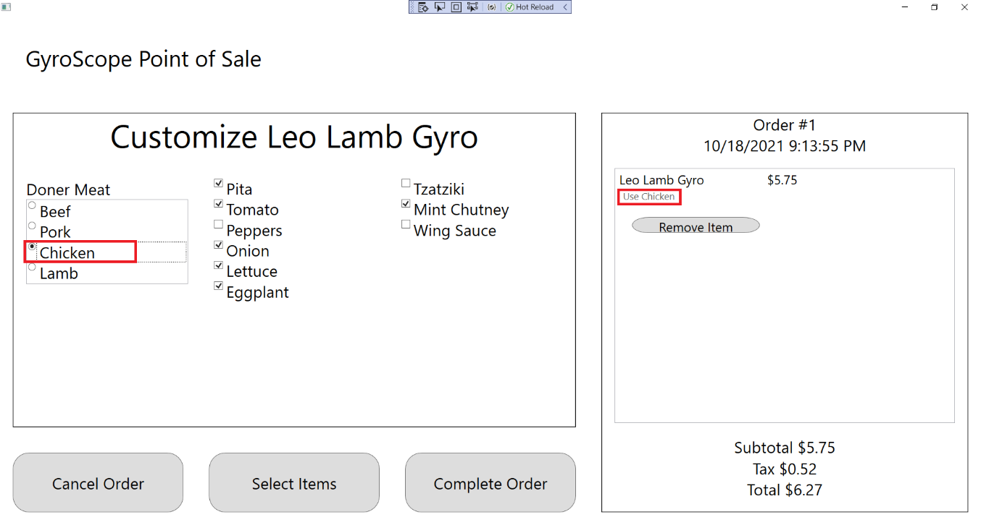

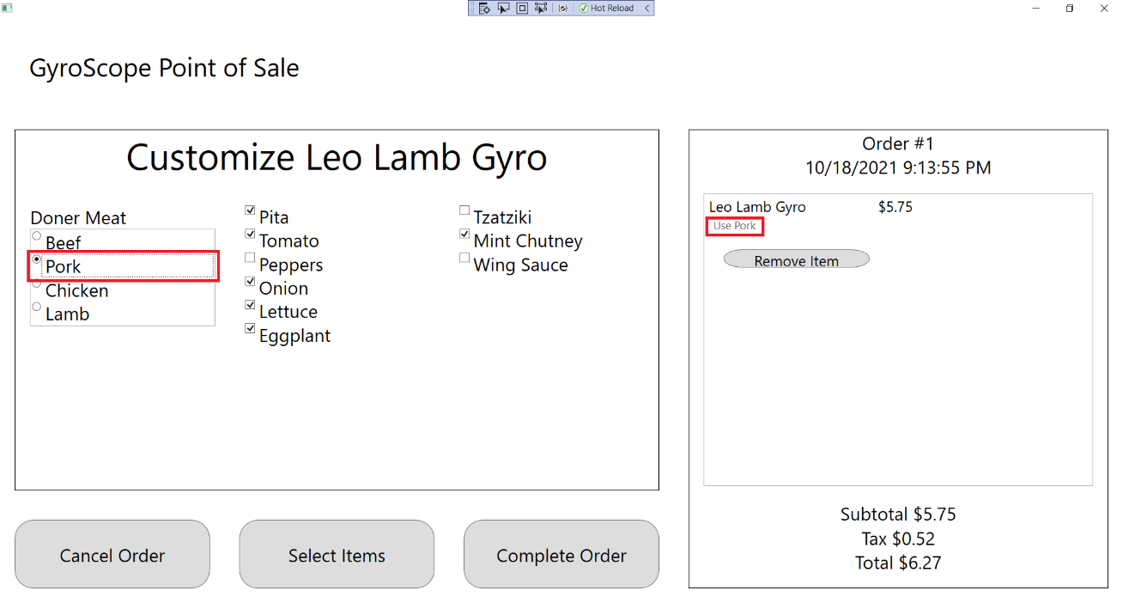

1. Uncheck Pita, Tomato, Onion, Lettuce, Eggplant and Mint Chutney. All unchecked items should show up underneath the menu item as “hold [item]”:

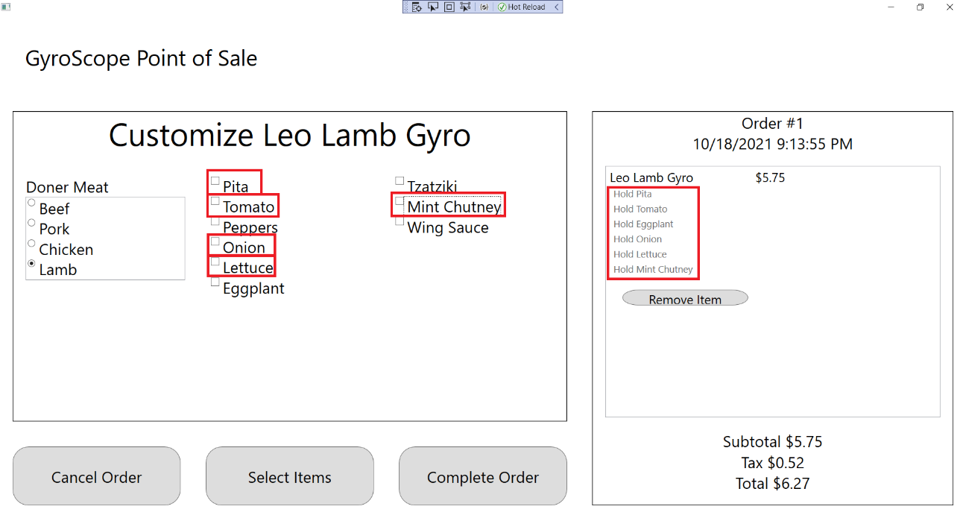

1. Check all boxes. All added items should show up underneath the menu item as “Add [item]”

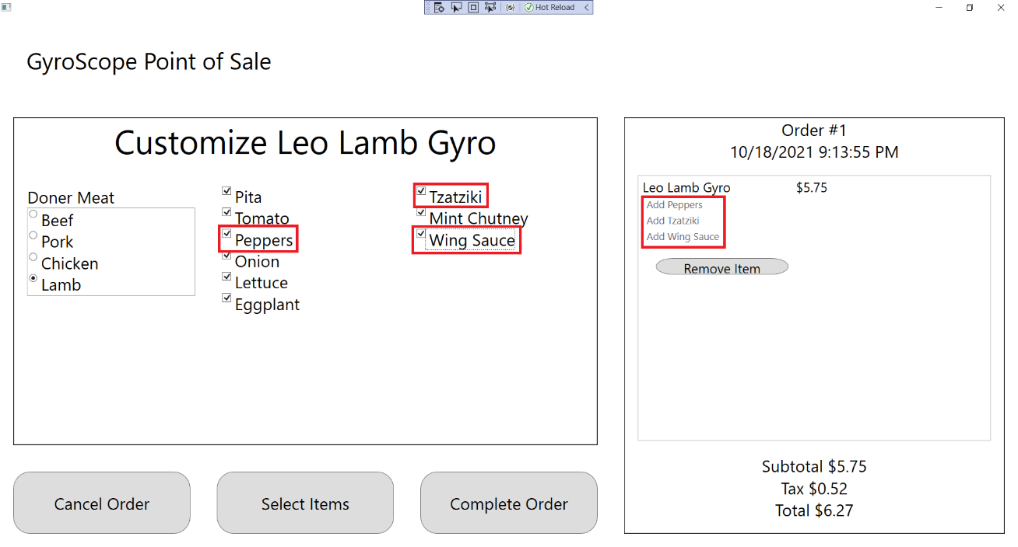

## Test #3 Adding and Customizing ScorpioSpicyGyro

1. Click on Scorpio Spicy Gyro:

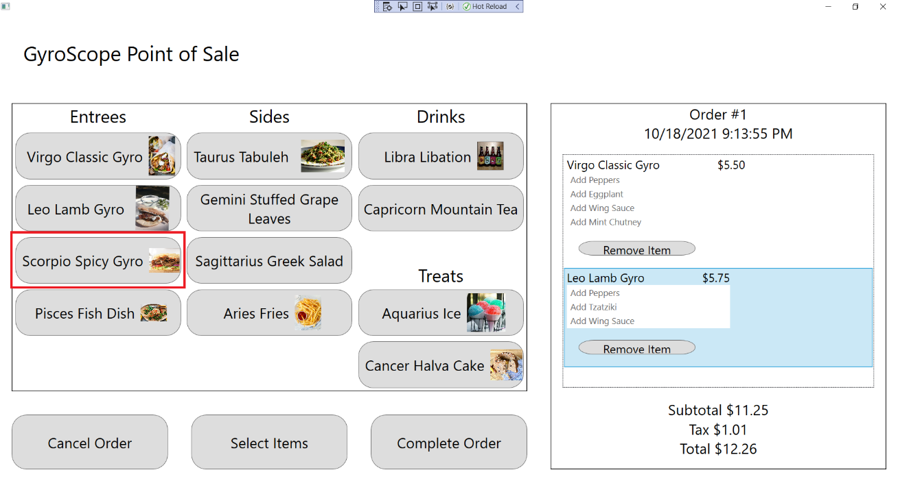

1. The customization screen should appear and a Leo Lamb Gyro should be added to the order, with Order #1, $6.20 Price, $17.45 Subtotal, $1.57 Tax and $19.02 Total being displayed:

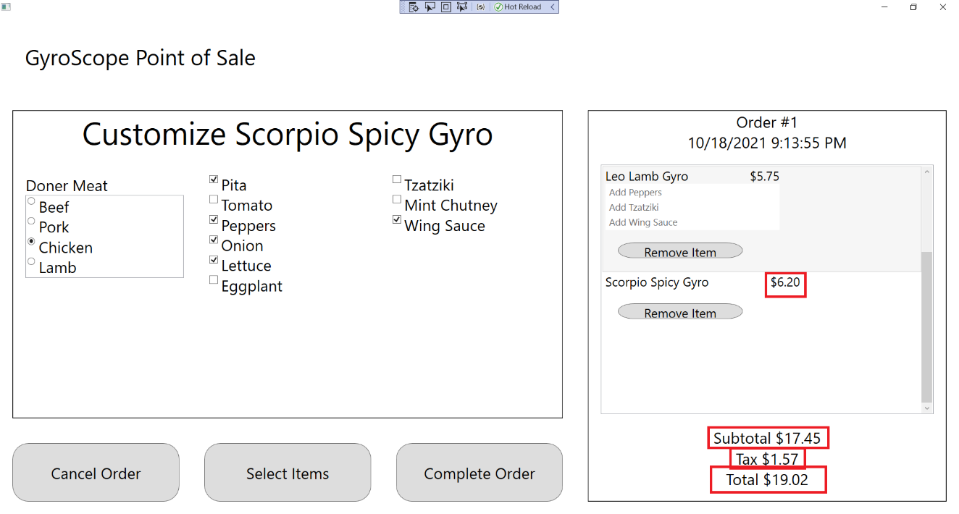

1. Change Doner Meat to Beef, Lamb, or Pork, and “Use Beef”, “Use Lamb”, or “Use Pork” should be displayed under the menu item:

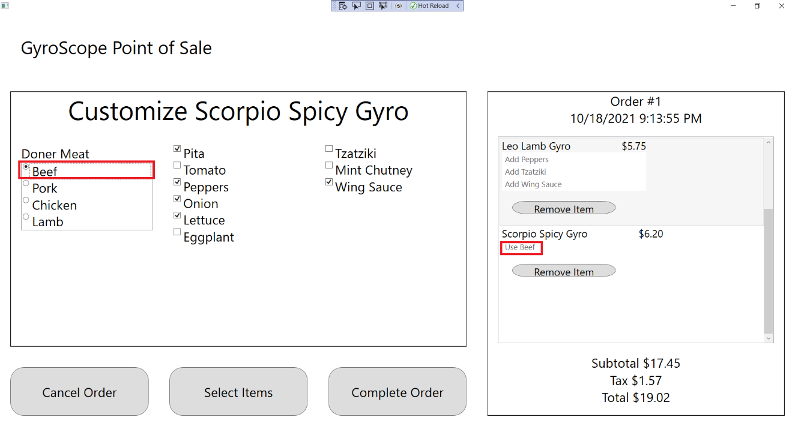

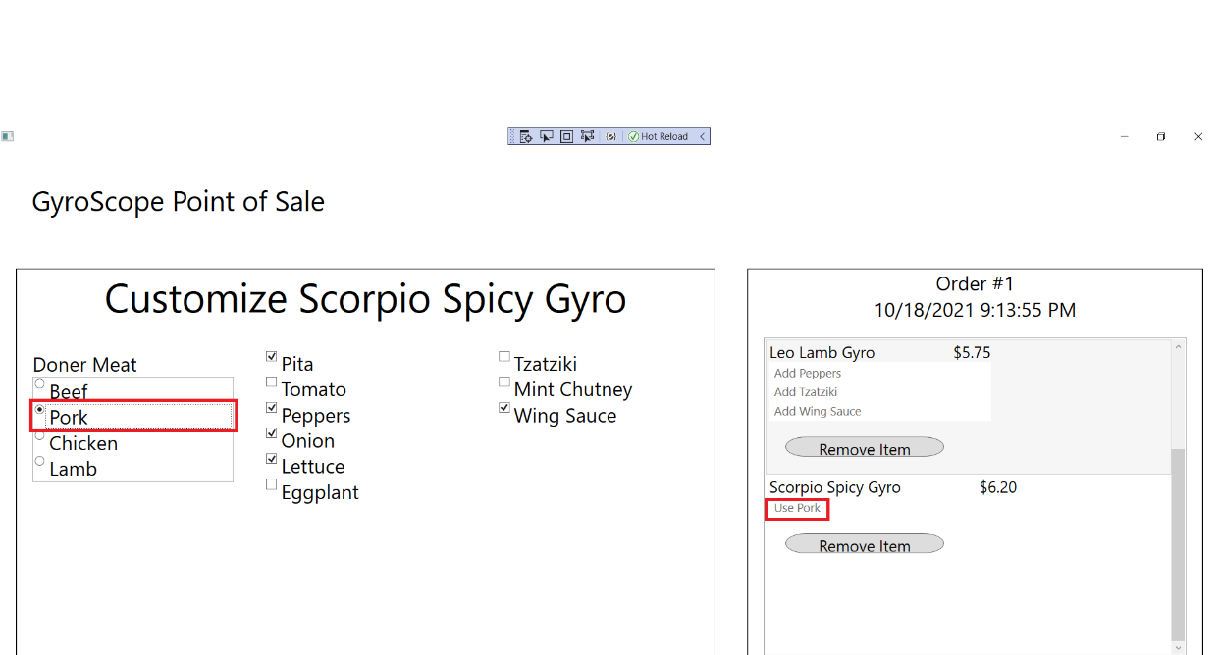

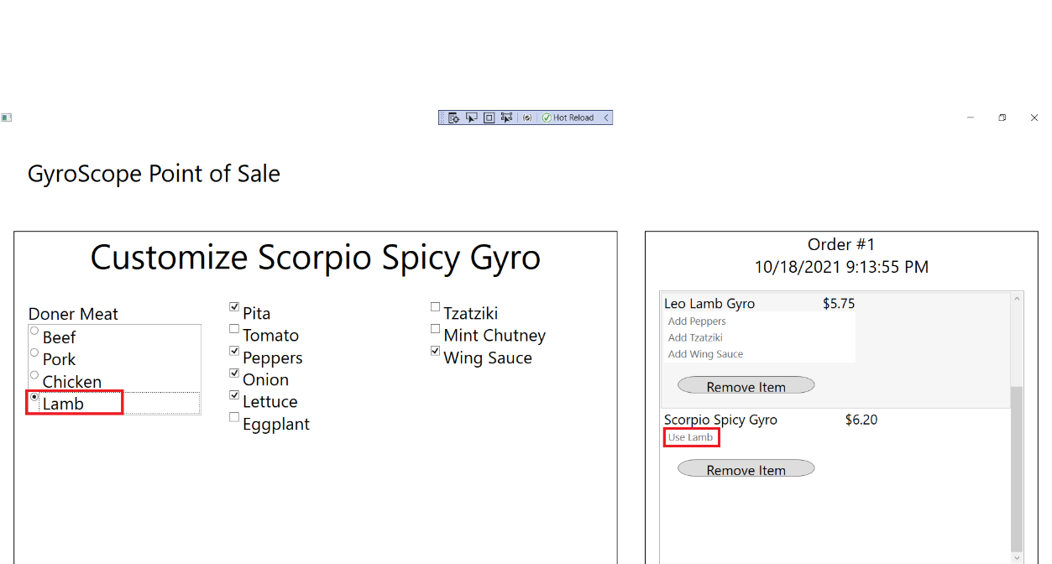

1. Uncheck Pita, Peppers, Onion, Lettuce, and Wing Sauce. All unchecked items should show up underneath the menu item as “hold [item]”:

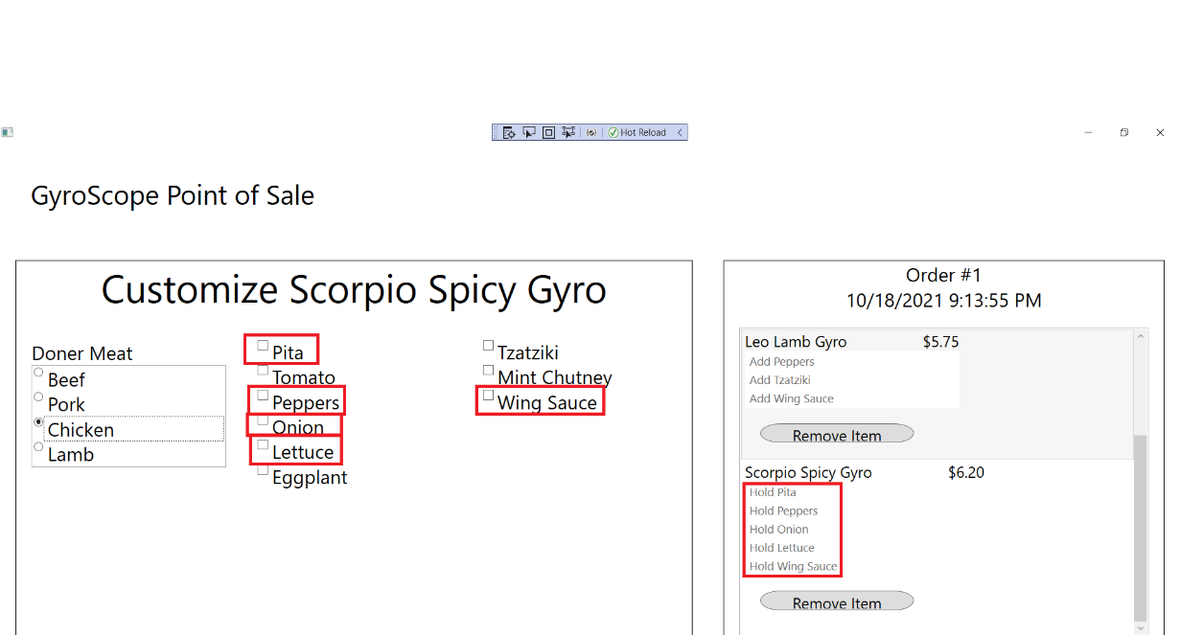

1. Check all boxes. All added items should show up underneath the menu item as “Add [item]”

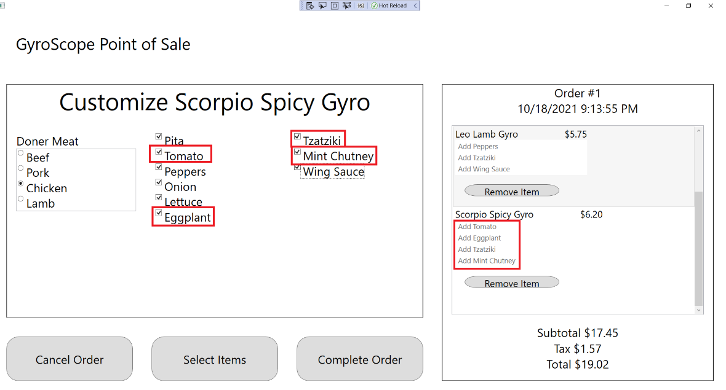

## Test #4 Adding and Customizing PiscesFishDish

1. Click on Pisces Fish Dish:

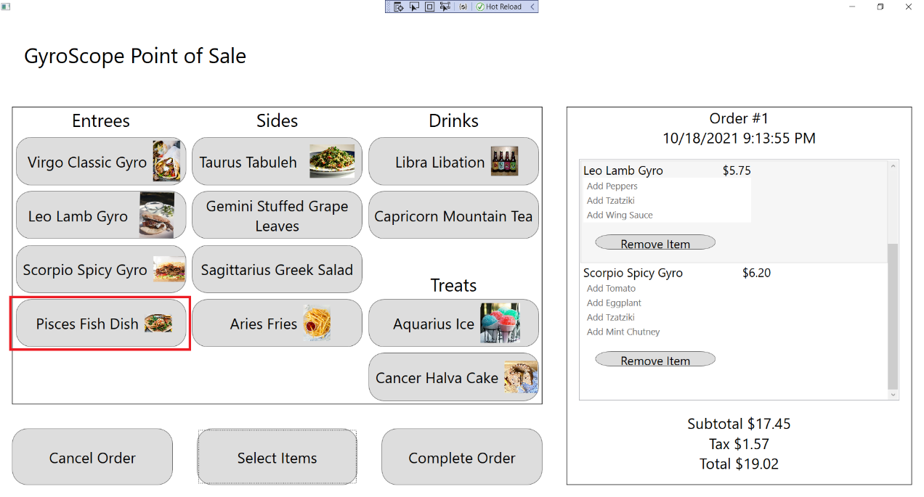

1. The customization screen should appear and a Pisces Fish Dish should be added to the order, with Order #1, $5.99 Price, $23.44 Subtotal, $2.11 Tax and $25.55 Total being displayed:

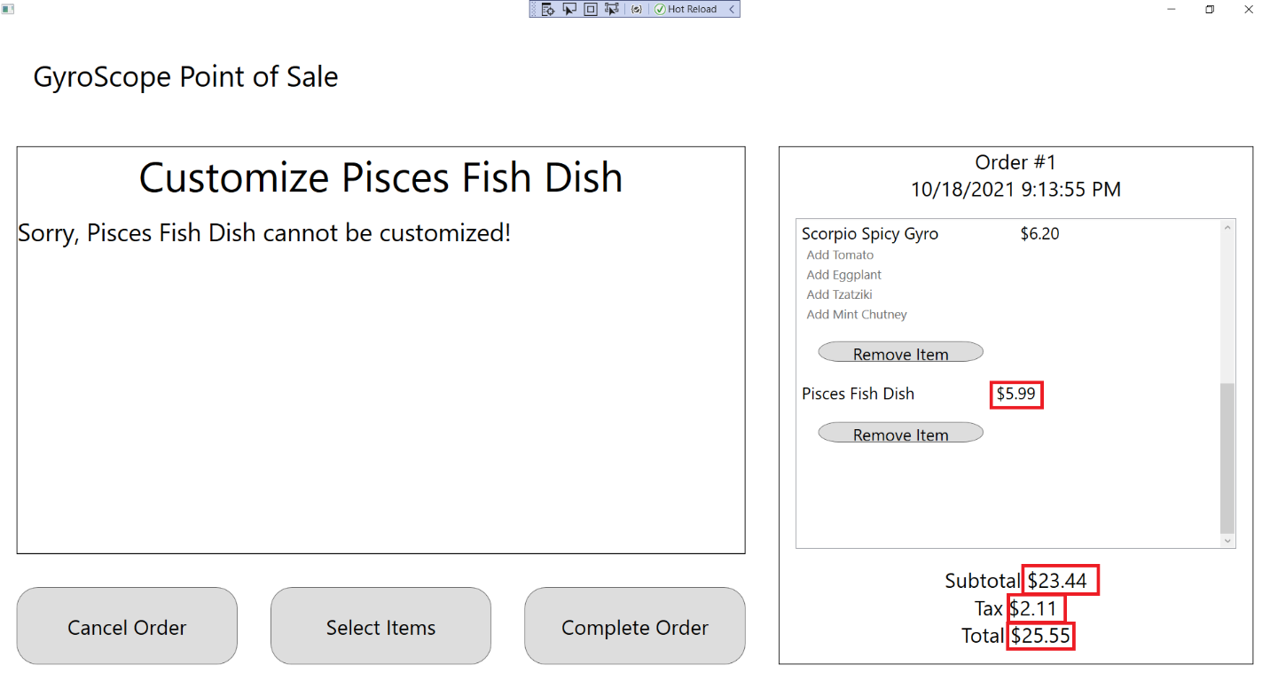

1. Press the “Select Items” button to return to the Menu Item Selection screen:

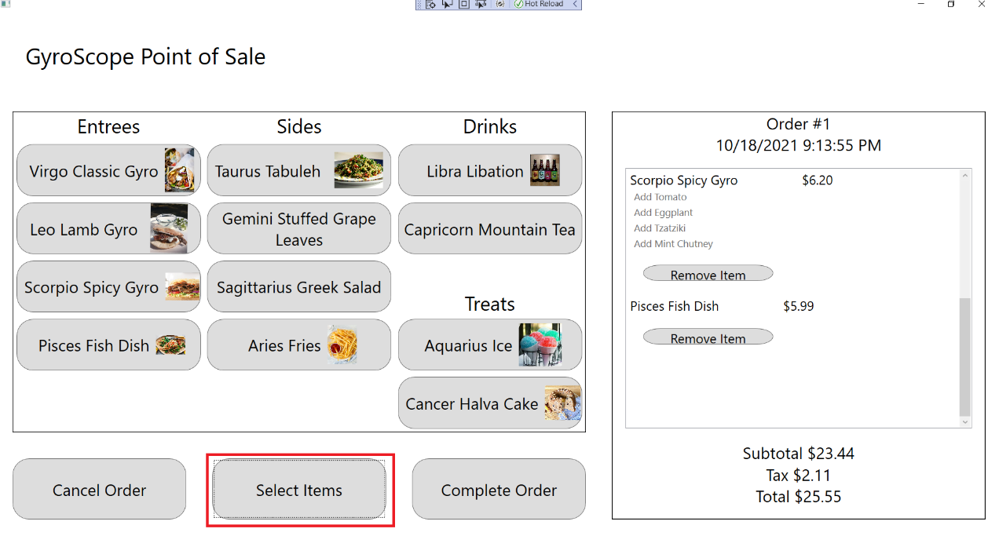

## Test #5 Adding and Customizing TaurusTabuleh

1. Click on Taurus Tabuleh:

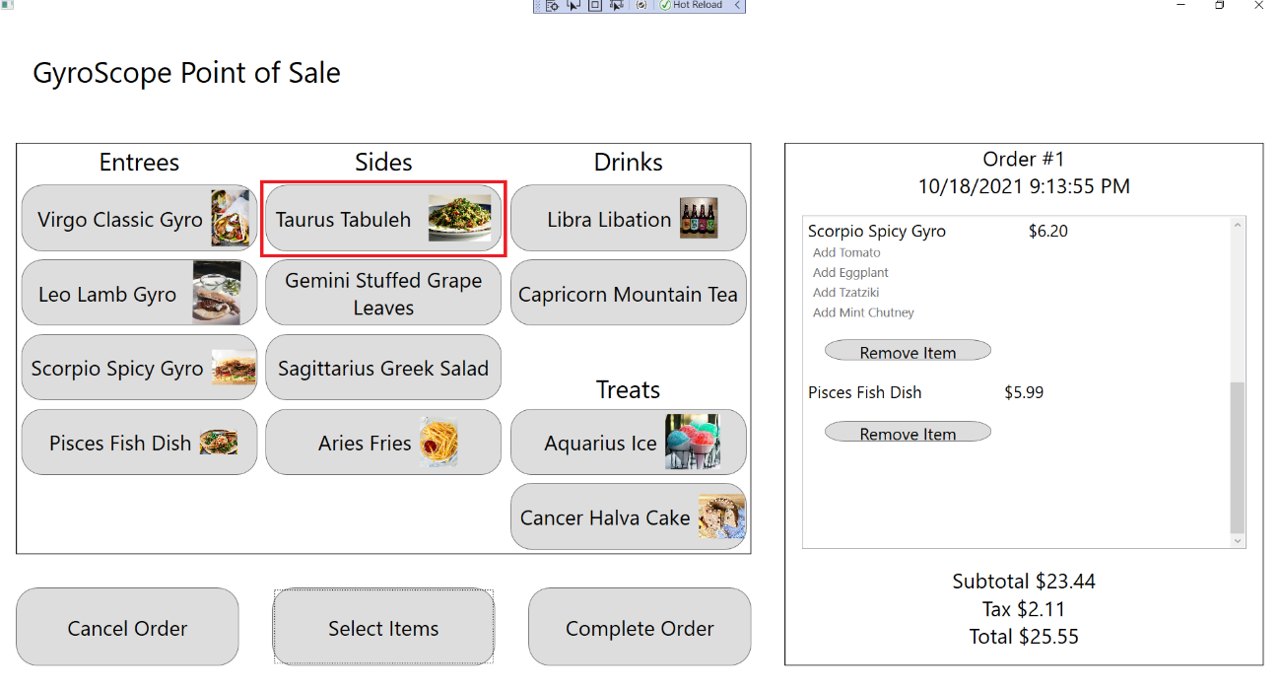

1. The customization screen should appear and a Taurus Tabuleh should be added to the order, with Order #1, $1.50 Price, $24.94 Subtotal, $2.24 Tax and $27.18 Total being displayed:

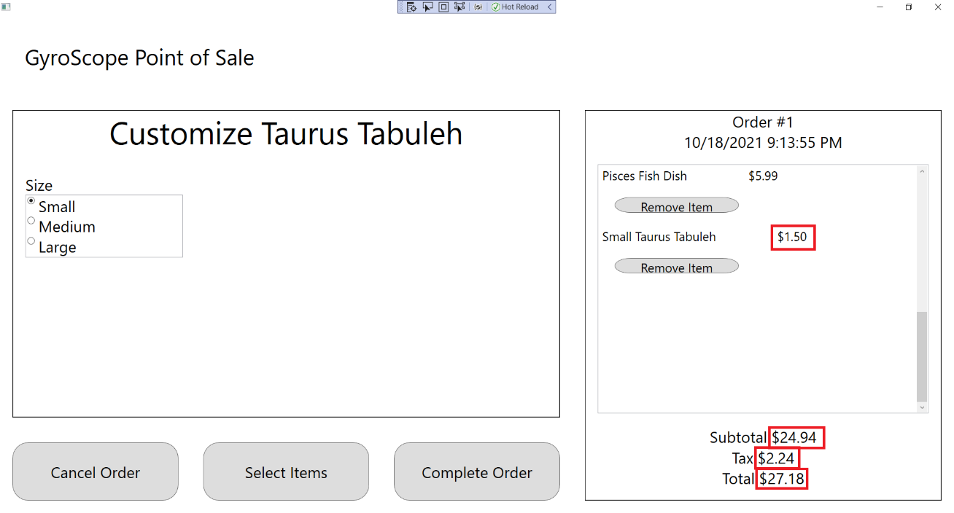

1. Change Size to Small, Medium, and Large. “Small”, “Medium, or “Large” should appear in front the Menu Item name, along with “$1.50”, $2.00”, and “$2.50”:

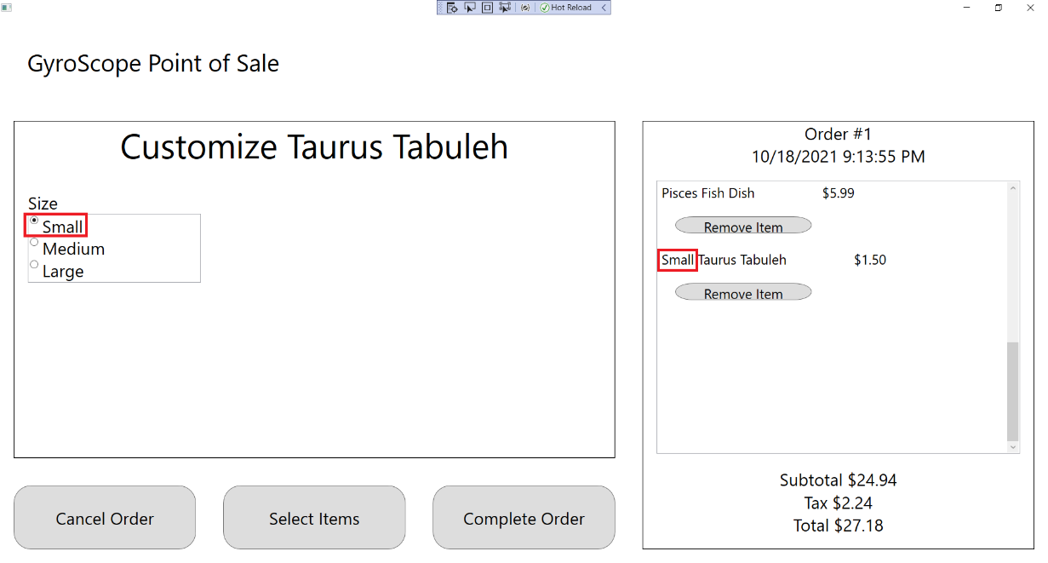

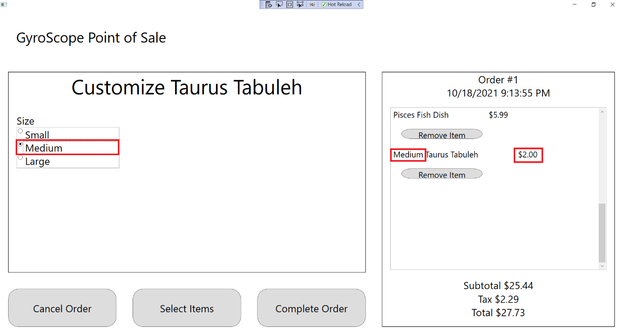

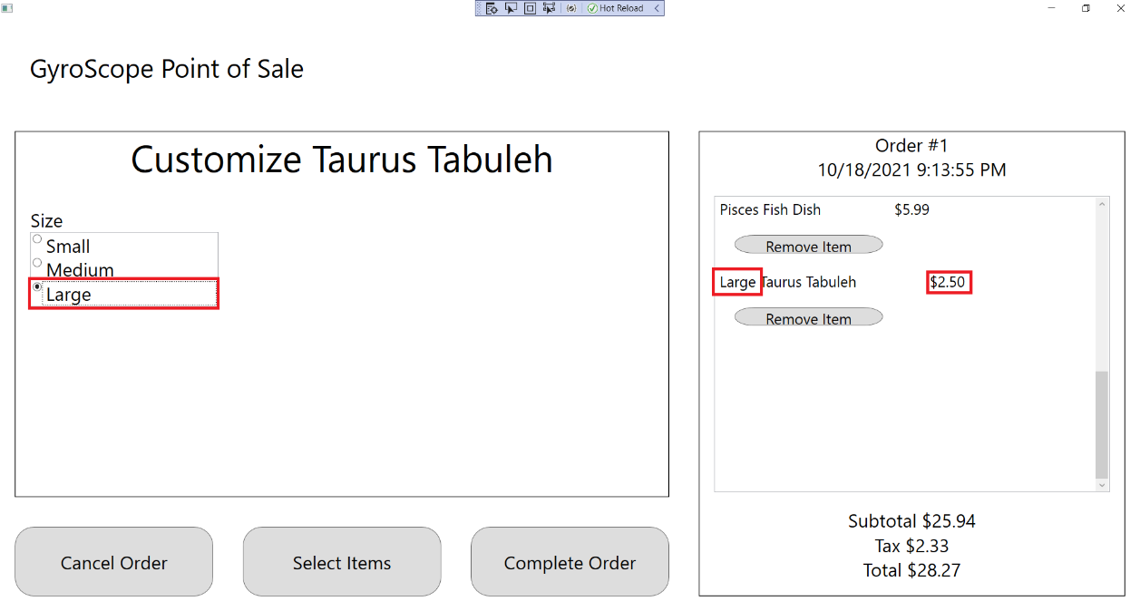

1. Press the “Select Items” button to return to the Menu Item Selection screen:

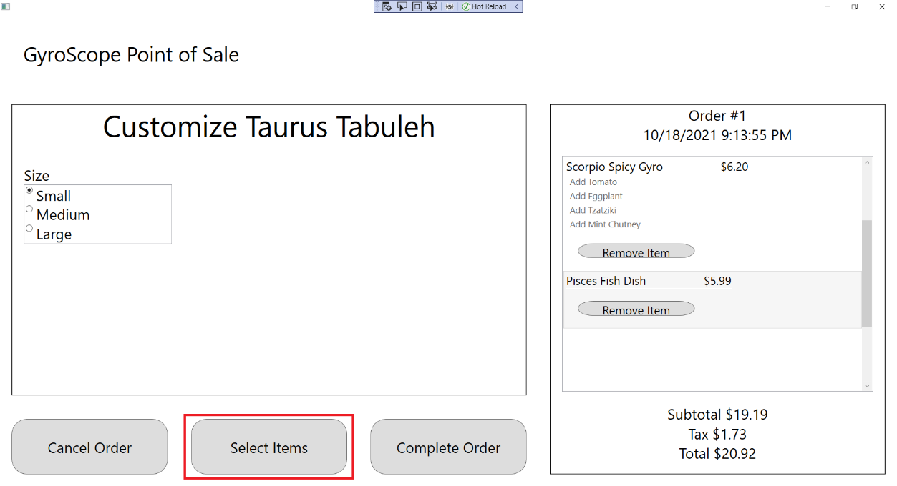

## Test #6 Adding and Customizing GeminiStuffedGrapeLeaves

1. Click on Gemini Stuffed Grape Leaves:

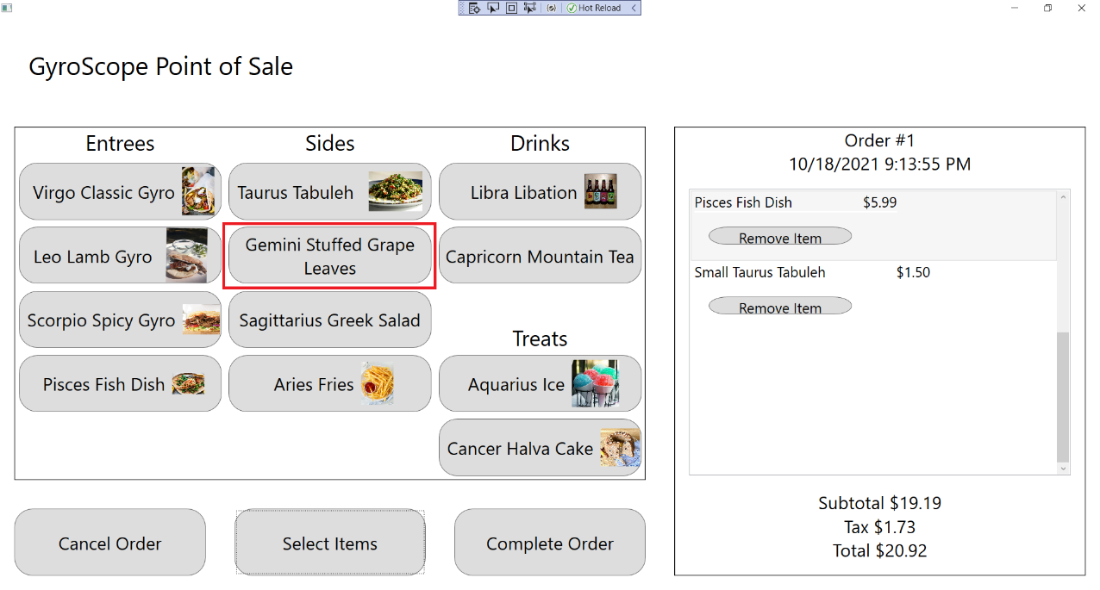

1. The customization screen should appear and a Pisces Fish Dish should be added to the order, with Order #1, $1.50 Price, $26.44 Subtotal, $2.38 Tax and $28.82 Total being displayed:

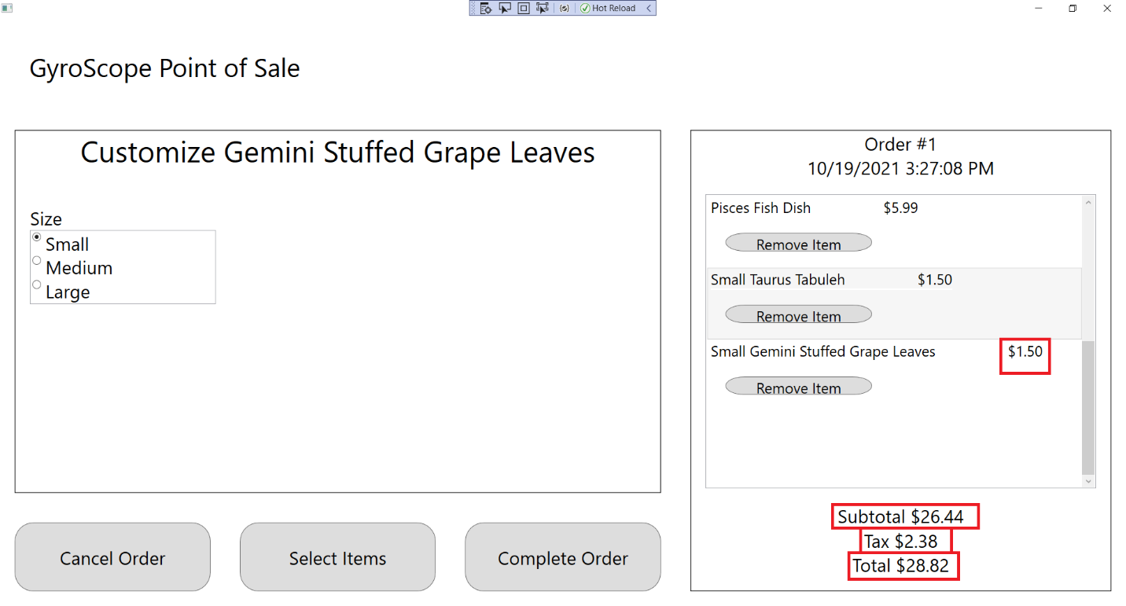

1. Change Size to Small, Medium, and Large. “Small”, “Medium, or “Large” should appear in front the Menu Item name, along with “$1.50”, $2.00”, and “$2.50”:

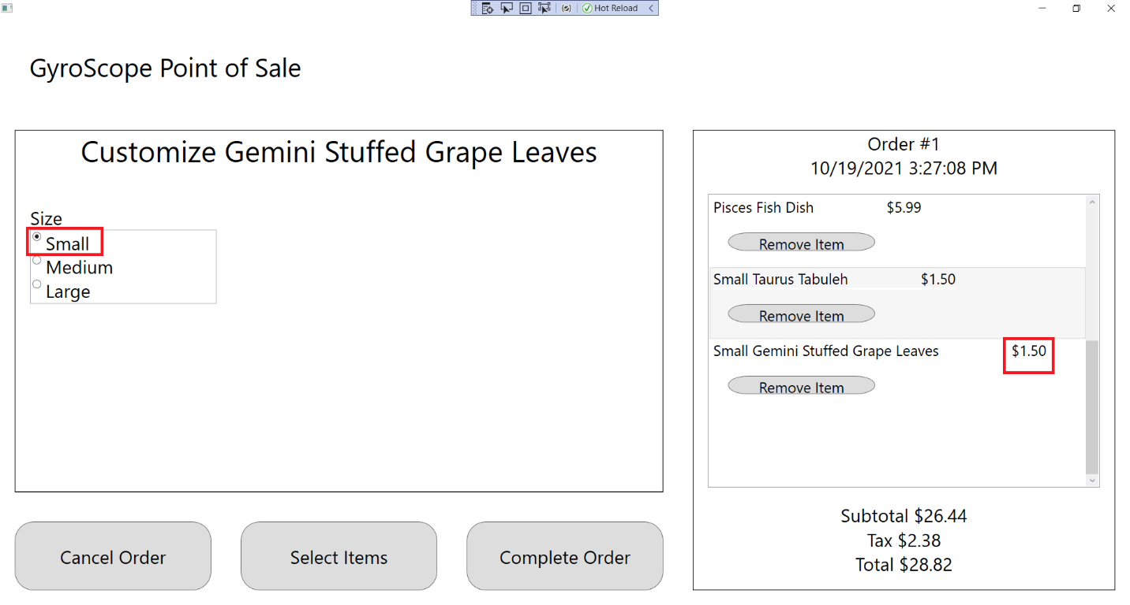

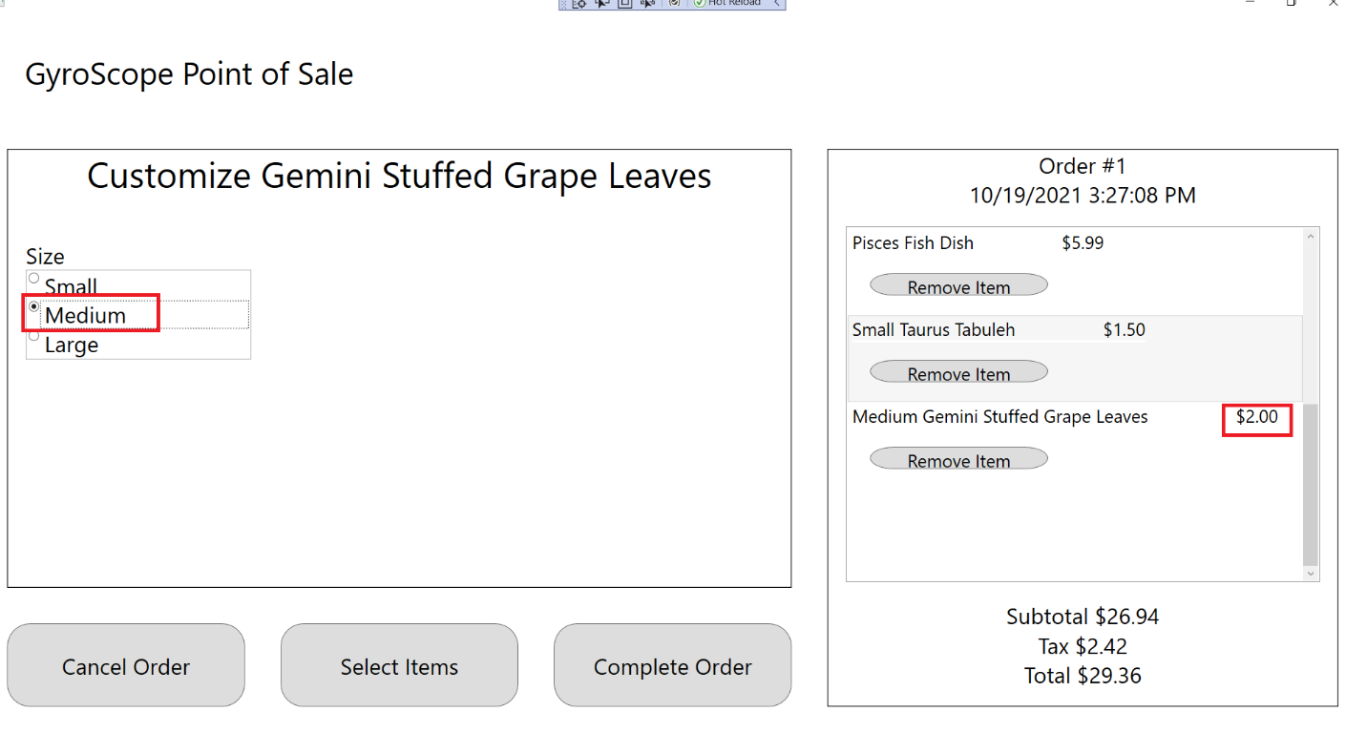

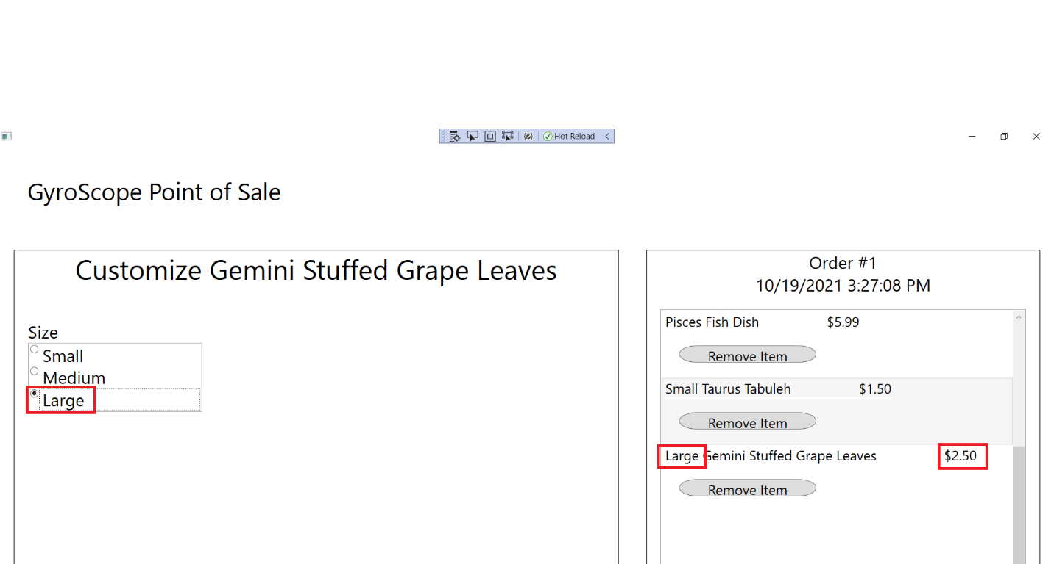

1. Press the “Select Items” button to return to the Menu Item Selection screen:

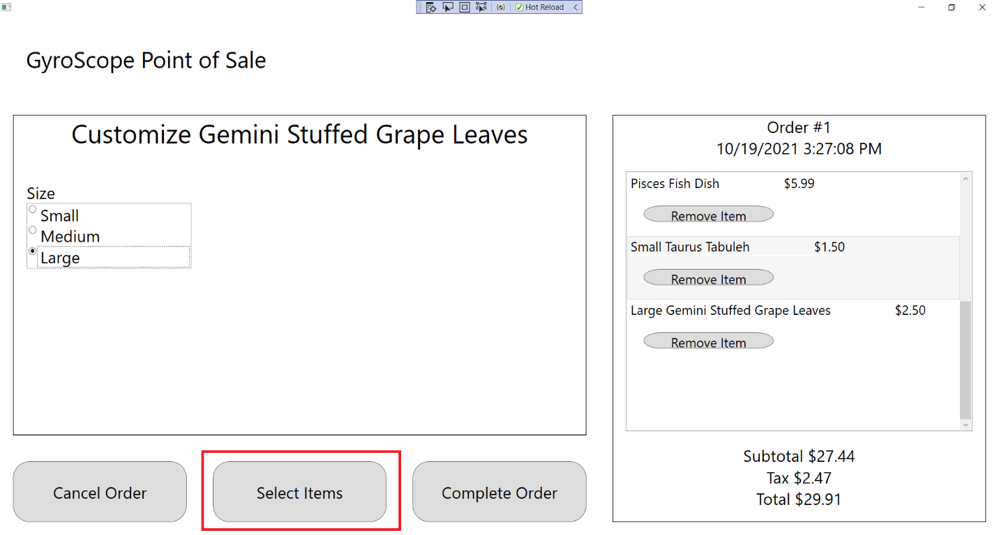

## Test #7 Adding and Customizing SagittariusGreekSalad

1. Click on Sagittarius Greek Salad:

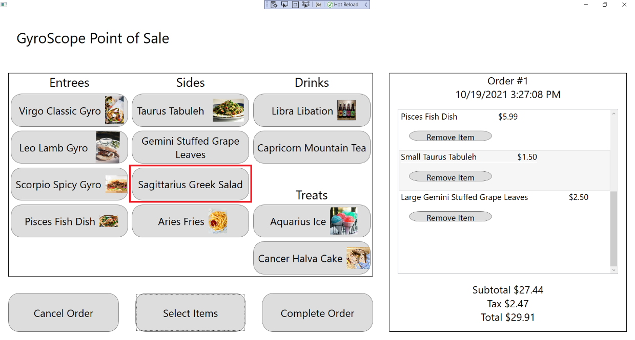

1. The customization screen should appear and a Sagittarius Greek Salad should be added to the order, with Order #1, $2.00 Price, $29.44 Subtotal, $2.65 Tax and $32.09 Total being displayed:

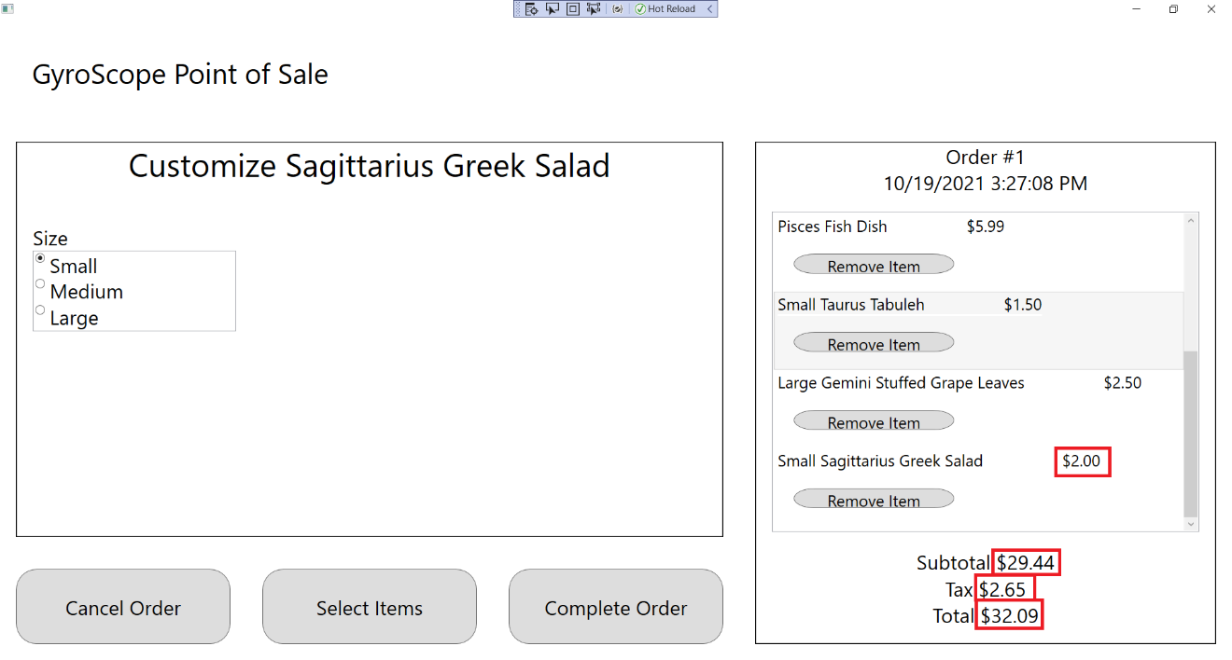

1. Change Size to Small, Medium, and Large. “Small”, “Medium, or “Large” should appear in front the Menu Item name, along with “$2.00”, $2.50”, and “$3.00”:

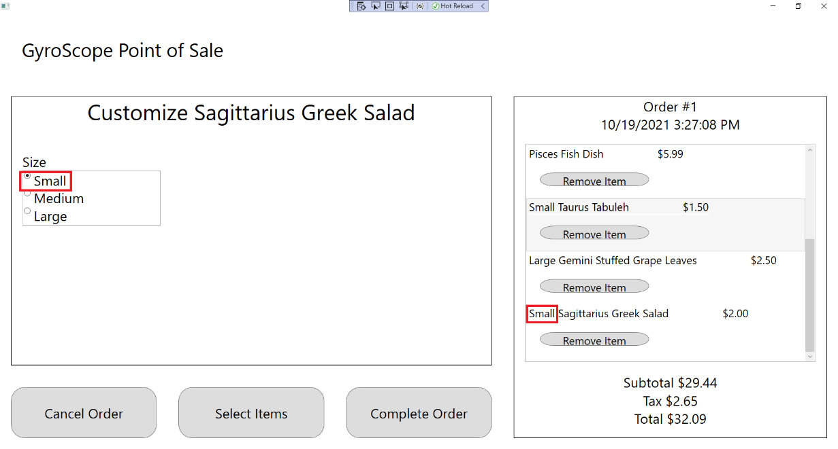

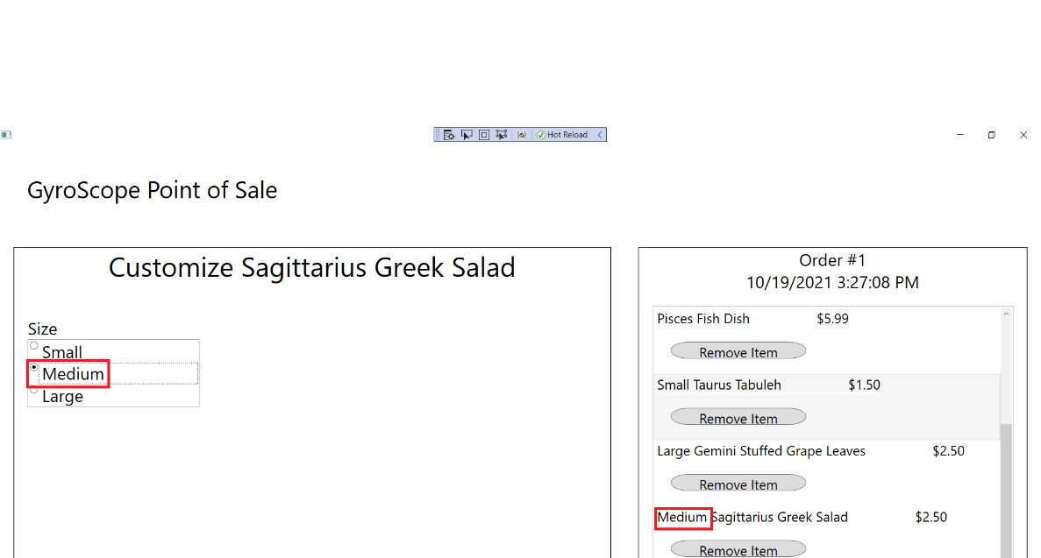

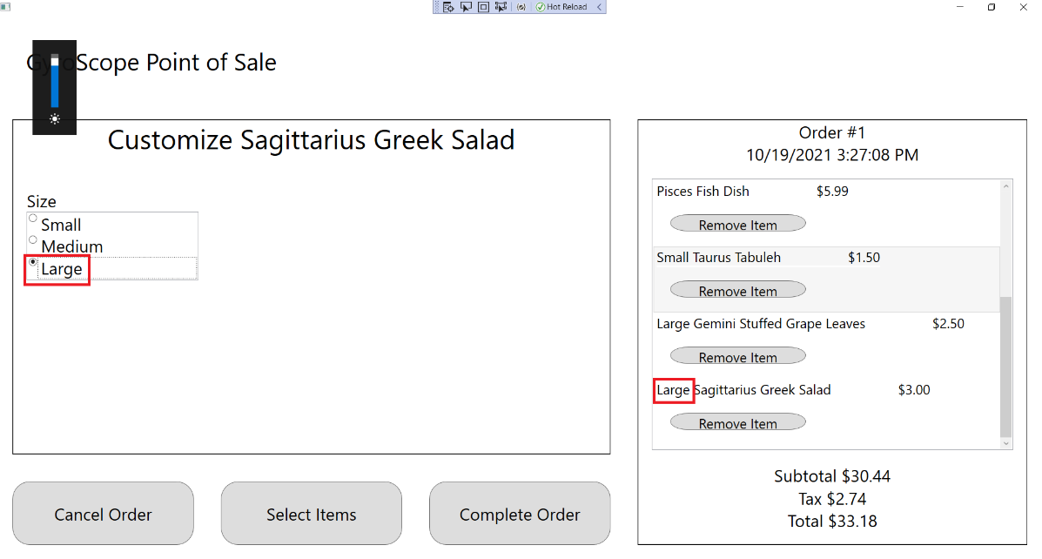

1. Press the “Select Items” button to return to the Menu Item Selection screen:

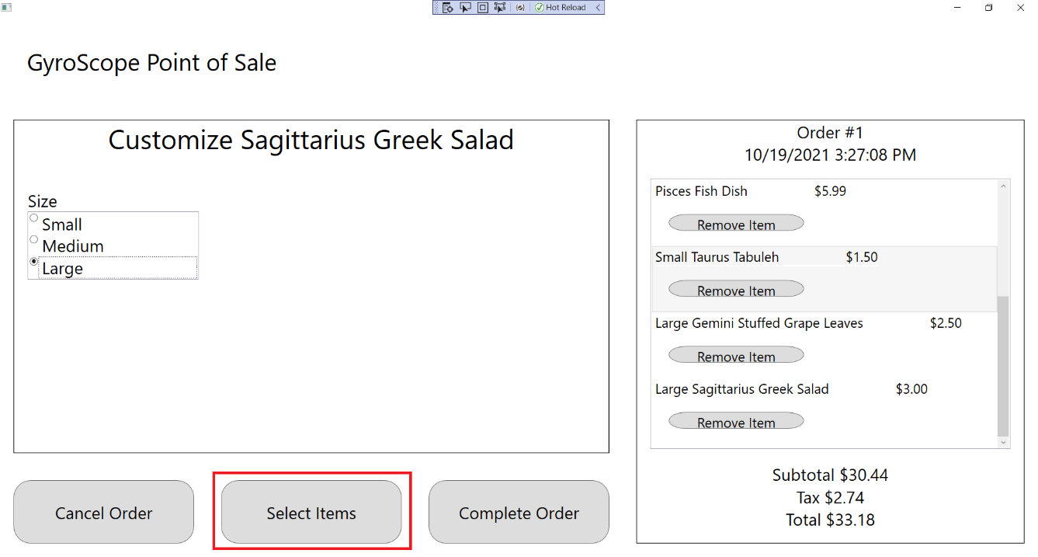

## Test #8 Adding and Customizing AriesFries

1. Click on Aries Fries:

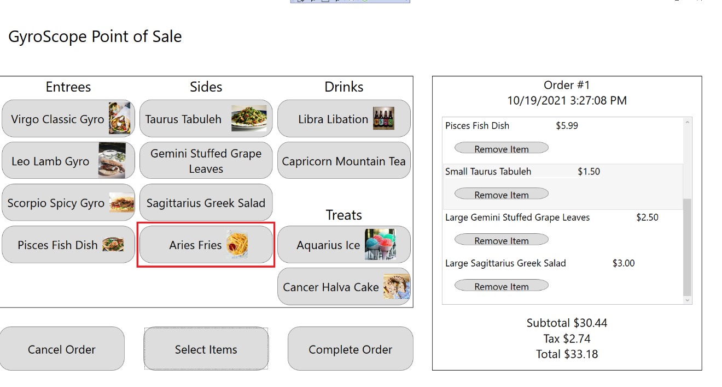

1. The customization screen should appear and a Aries Fries should be added to the order, with Order #1, $3.00 Price, $31.94 Subtotal, $2.87 Tax and $34.81 Total being displayed:

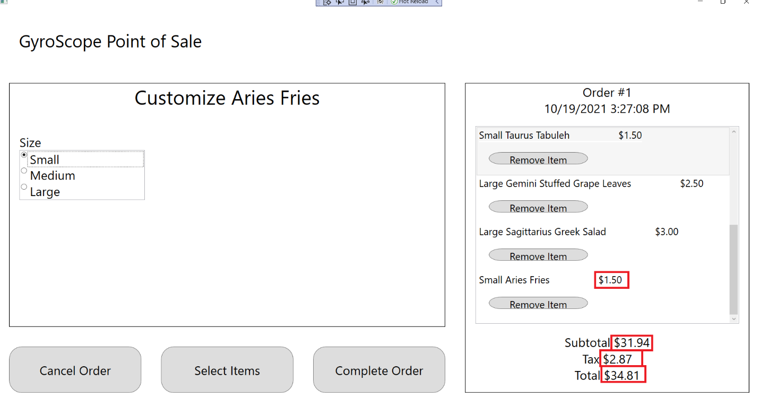

1. Change Size to Small, Medium, and Large. “Small”, “Medium, or “Large” should appear in front the Menu Item name, along with “$1.50”, $2.00”, and “$2.50”:

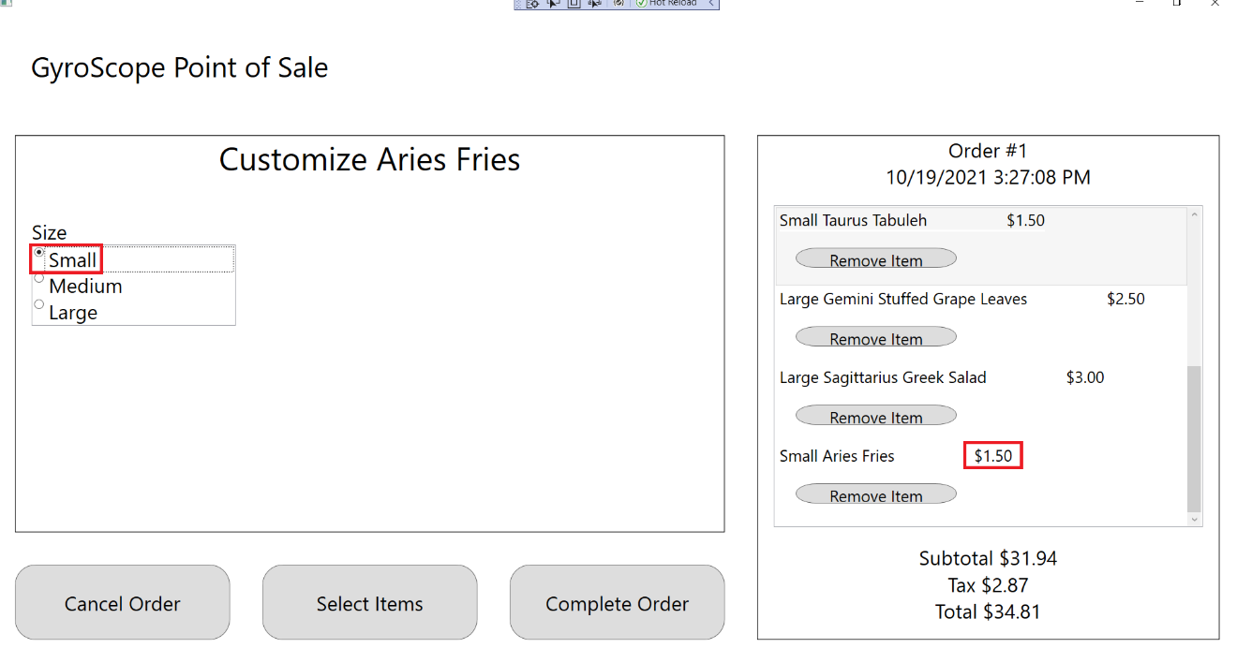

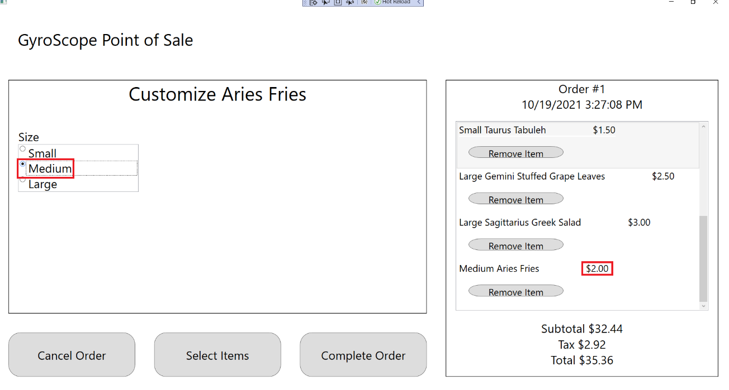

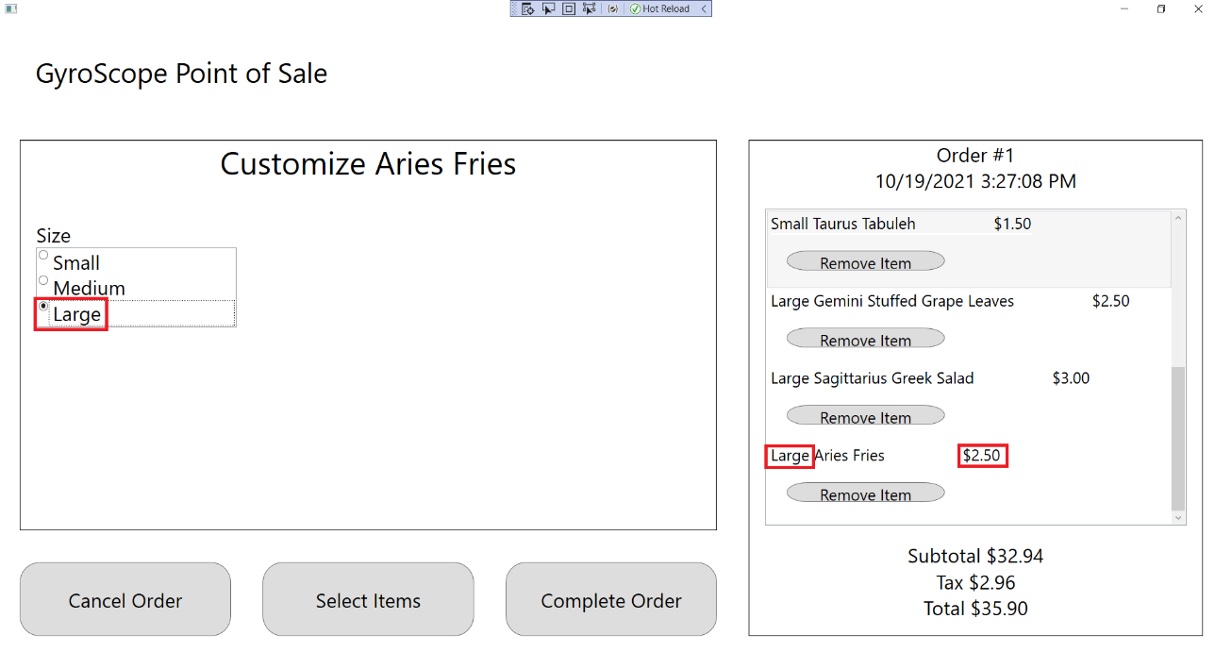

1. Press the “Select Items” button to return to the Menu Item Selection screen:

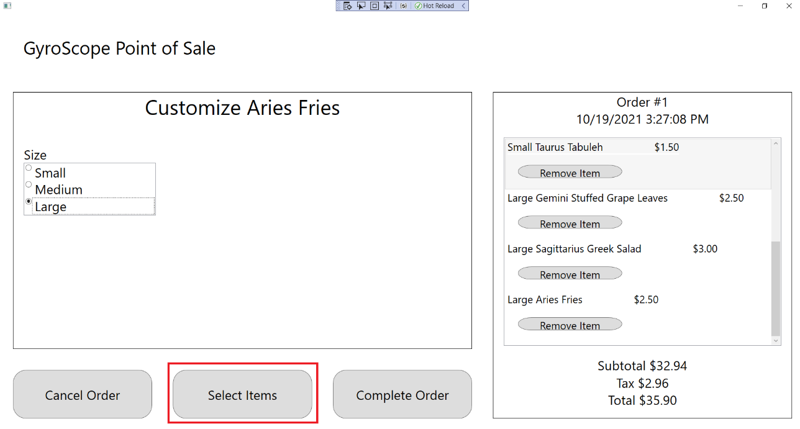

## Test #9 Adding and Customizing LibraLibation

1. Click on Libra Libation:

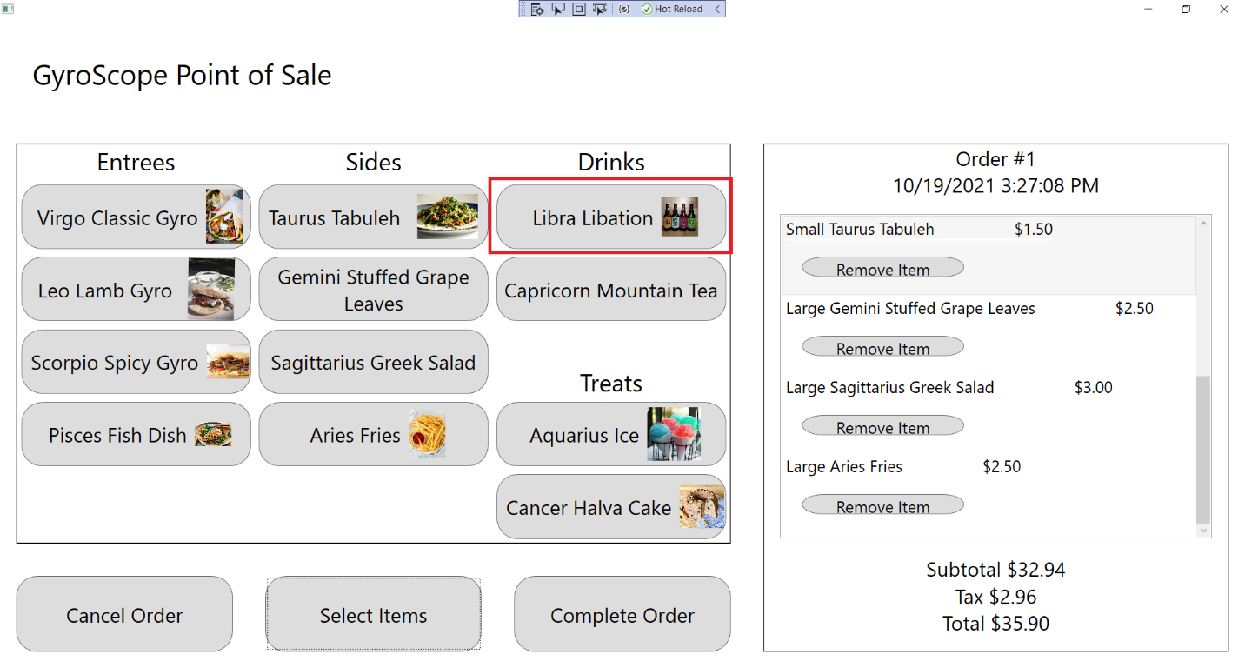

1. The customization screen should appear and a Libra Libation should be added to the order, with Order #1, $1.00 Price, $33.94 Subtotal, $3.05 Tax and $36.99 Total being displayed:

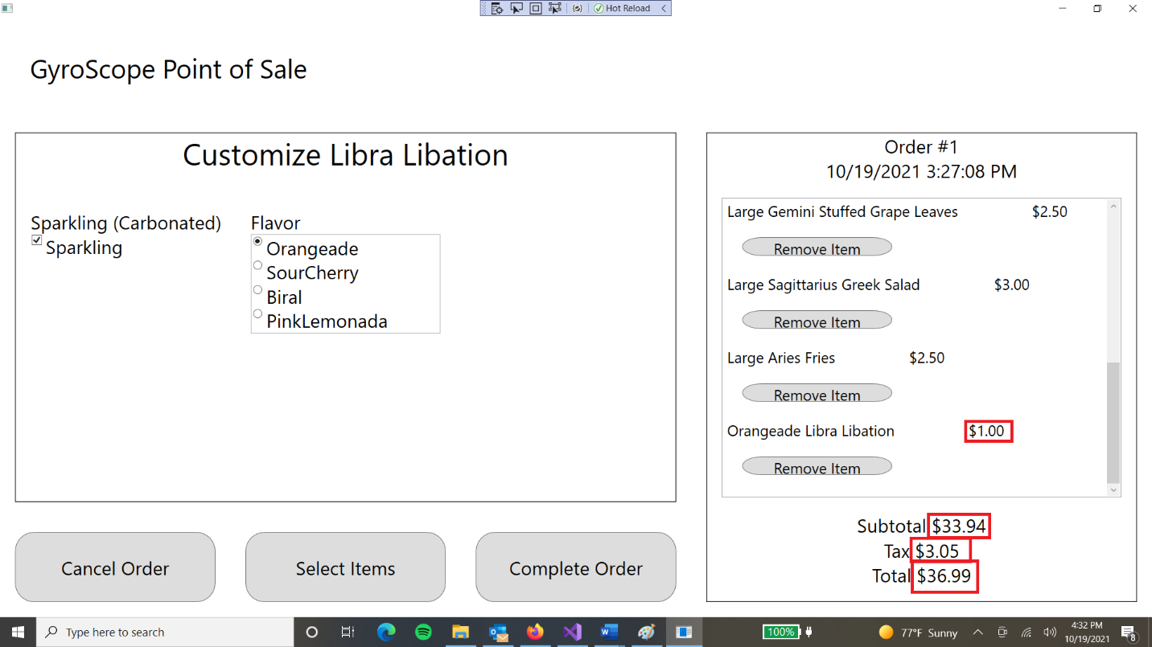

1. Uncheck the “Sparkling” box. “Hold Sparkling” should appear below the Menu Item:

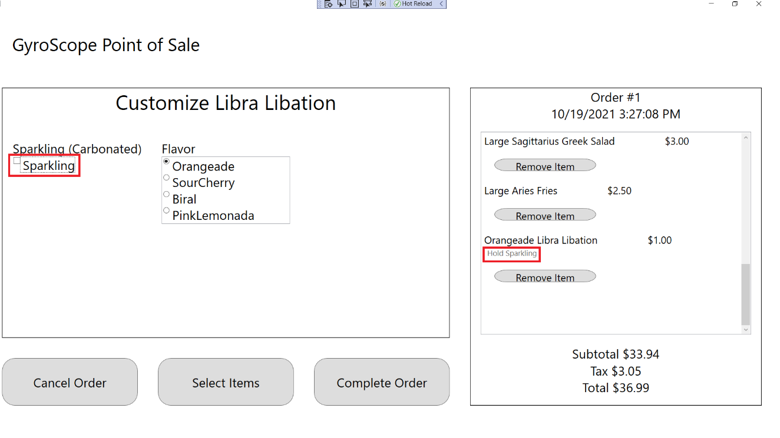

1. Select each Flavor one by one. The name of the menu item should change for each flavor.

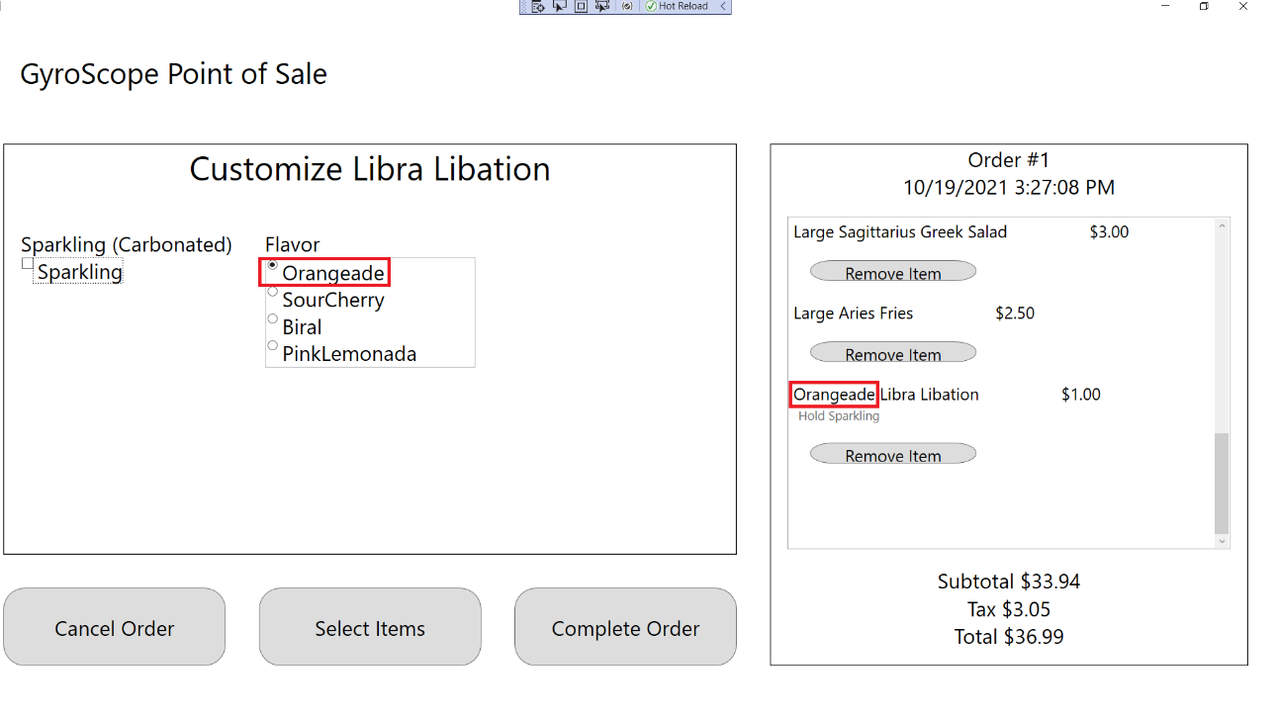

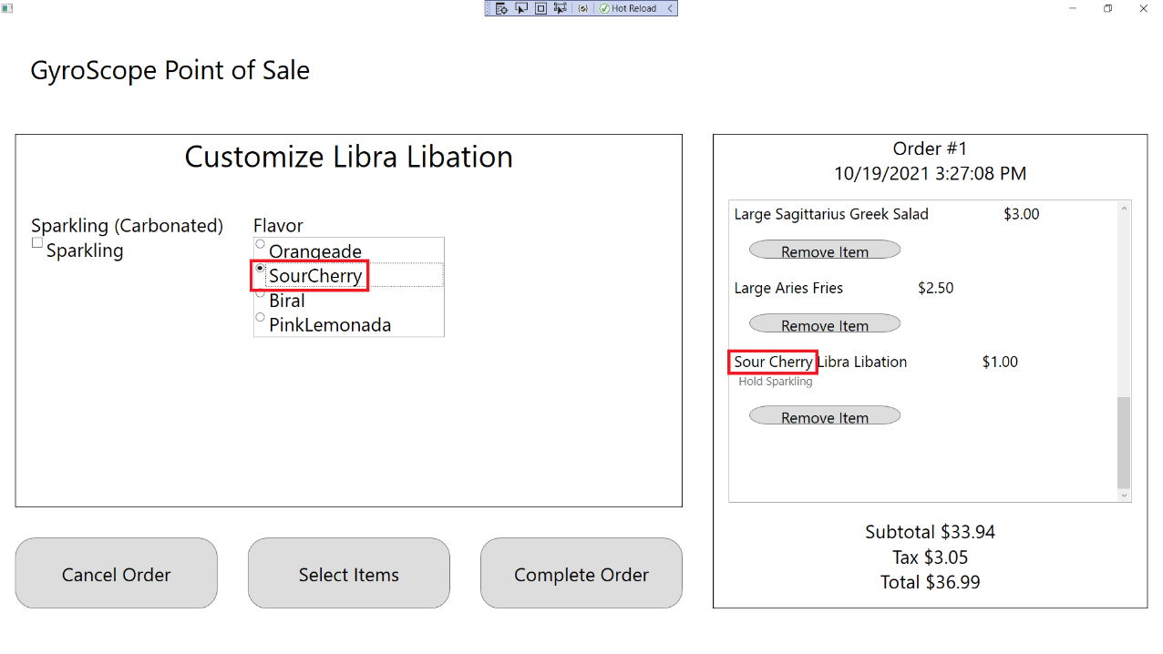

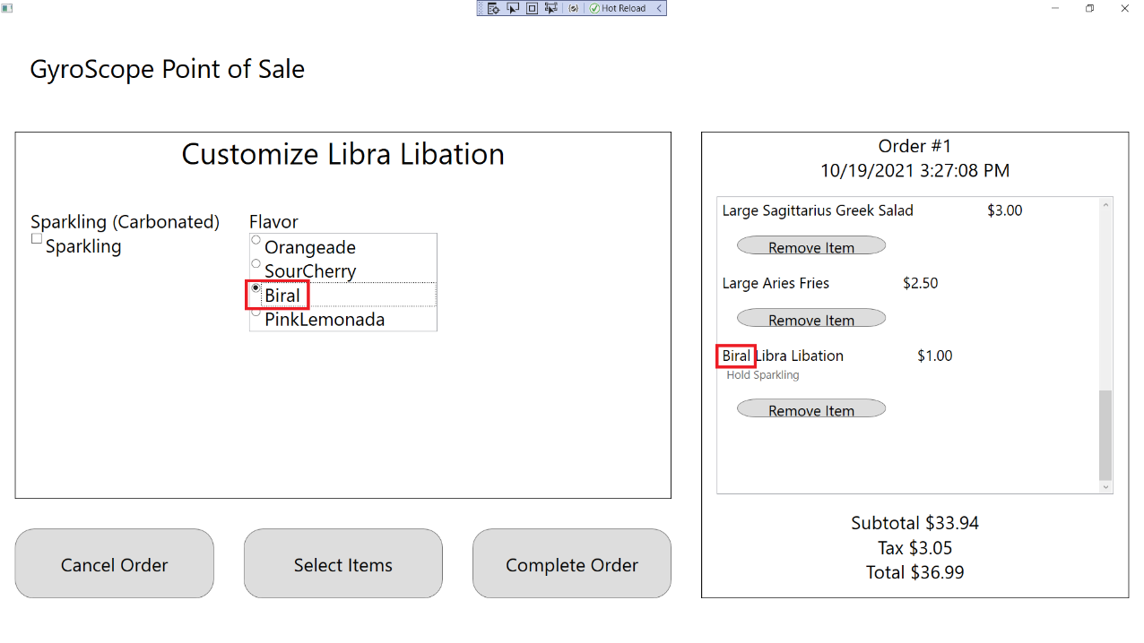

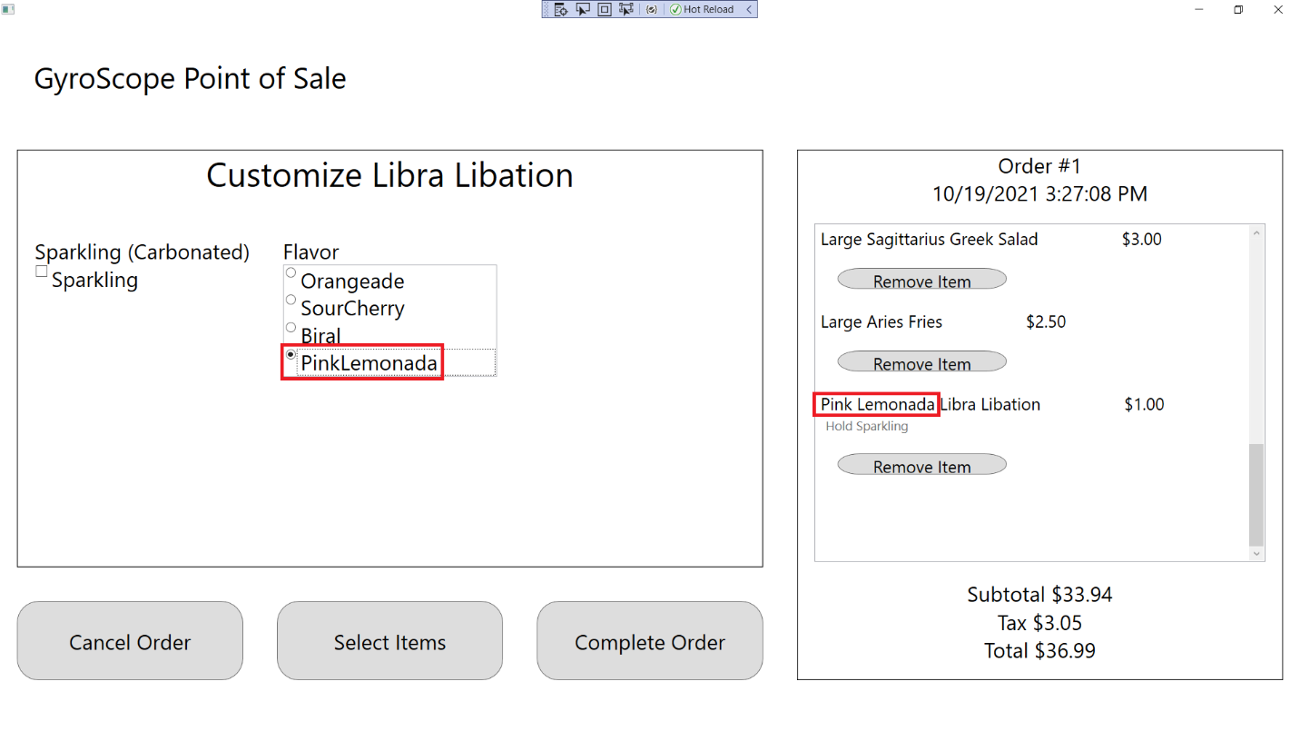

1. Press the “Select Items” button to return to the Menu Item Selection screen:

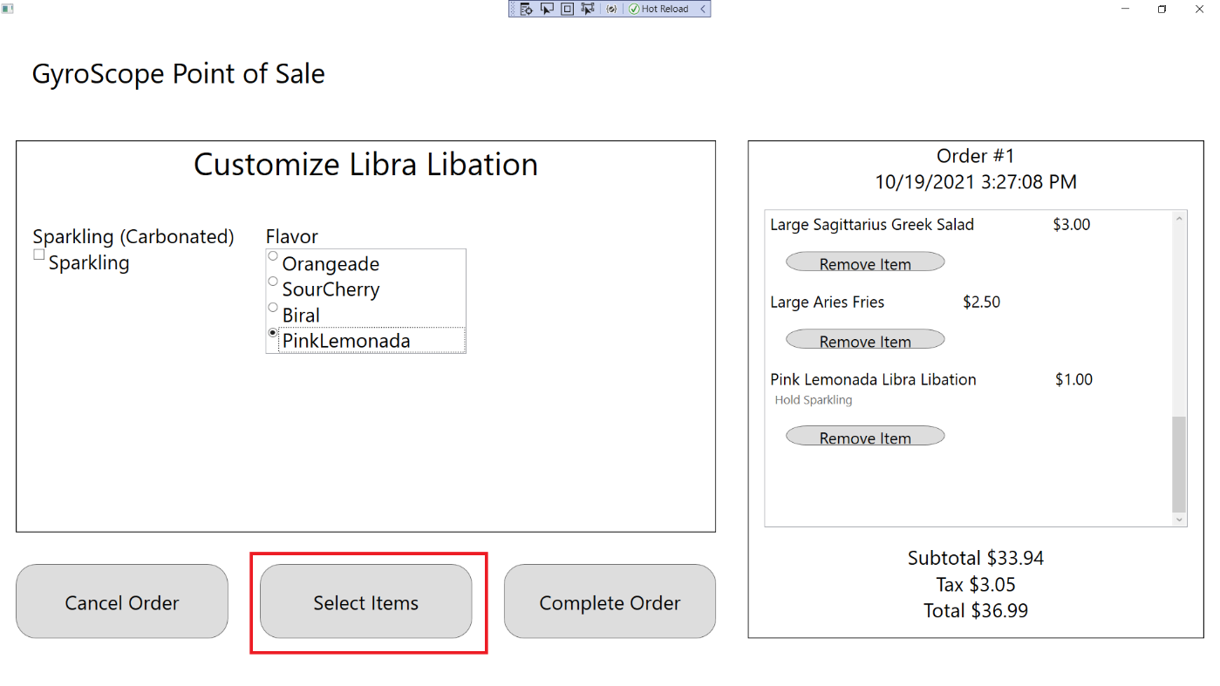

## Test #10 Adding and Customizing CapricornMountainTea

1. Click on Capricorn Mountain Tea

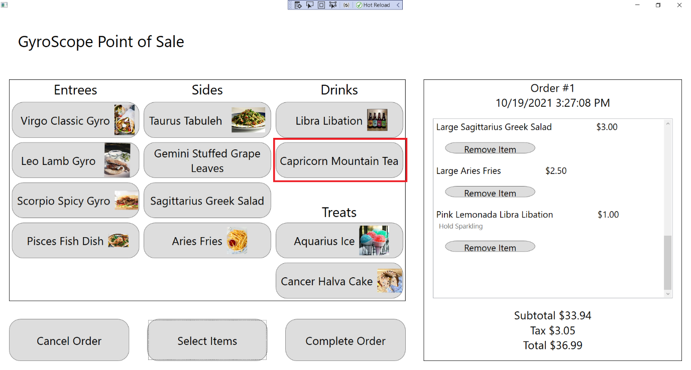

1. The customization screen should appear and a Capricorn Mountain Tea should be added to the order, with Order #1, $2.50 Price, $36.44 Subtotal, $3.28 Tax and $39.72 Total being displayed:

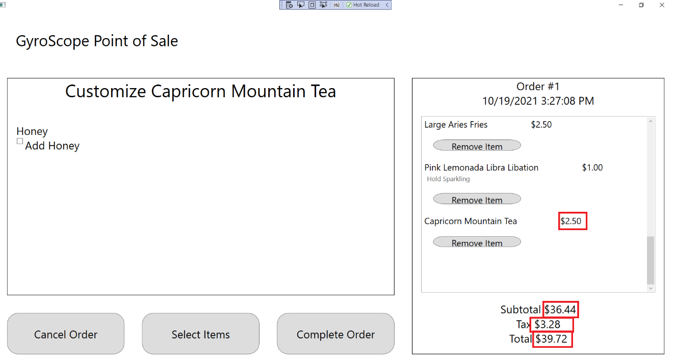

1. Check the Honey box. “Add Honey” should appear below the menu item:

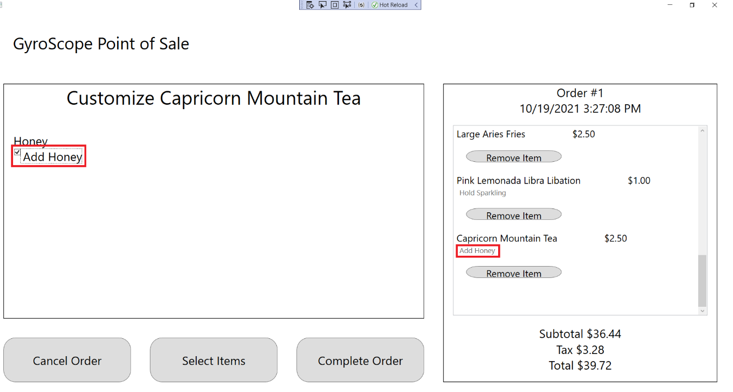

1. Click the “Select Items” button to return to the Menu Item Selection screen:

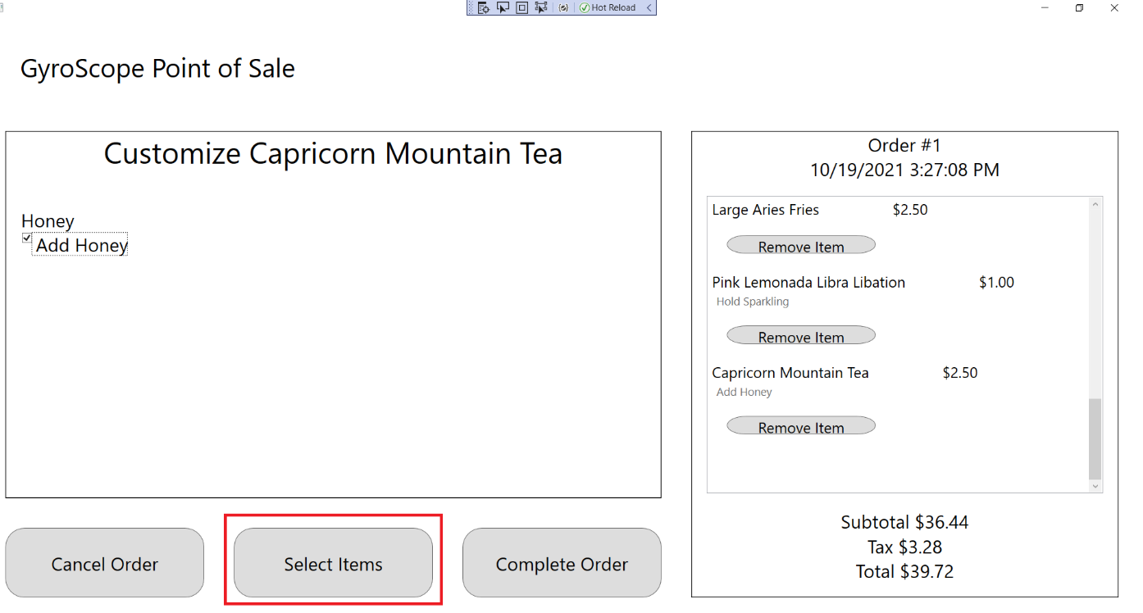

## Test #11 Adding and Customizing AquariusIce

1. Click on Aquarius Ice:

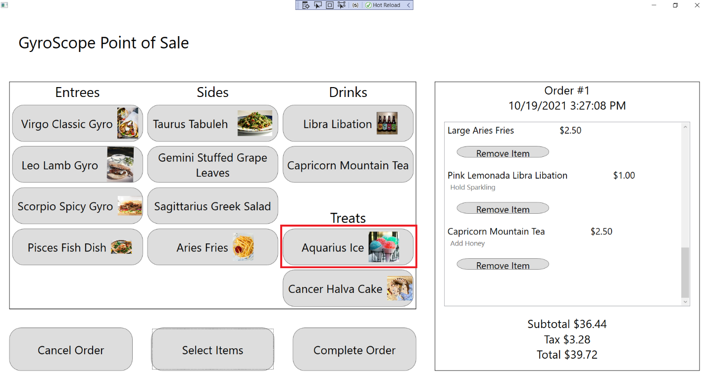

1. The customization screen should appear and an Aquarius Ice should be added to the order, with Order #1, $2.00 Price, $38.44 Subtotal, $3.46 Tax and $41.90 Total being displayed:

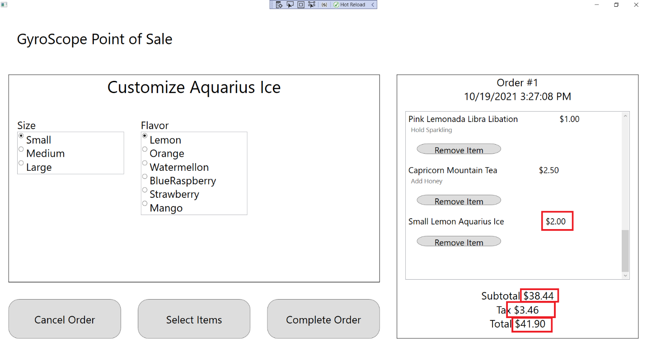

1. Change Size to Small, Medium, and Large. “Small”, “Medium, or “Large” should appear in front the Menu Item name, along with “$2.00”, $2.50”, and “$3.00”:

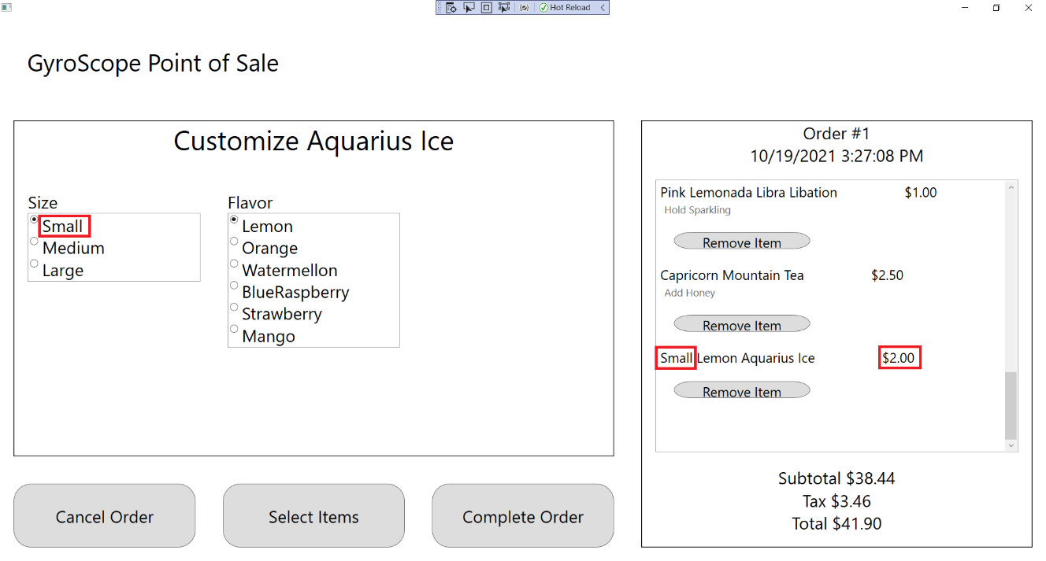

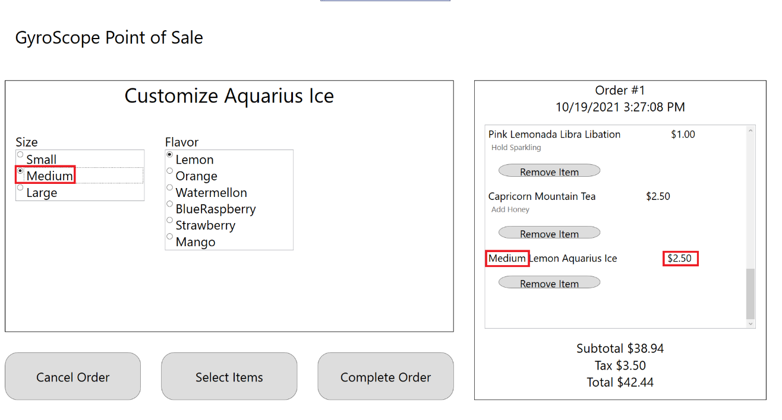

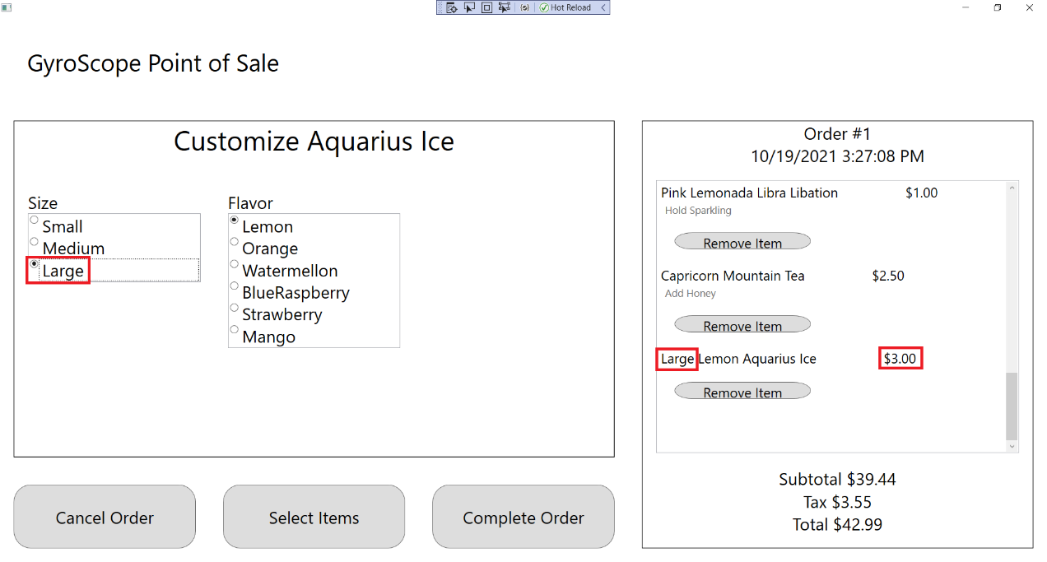

1. Click on each Flavor. The name of the Aquarius Ice should change:

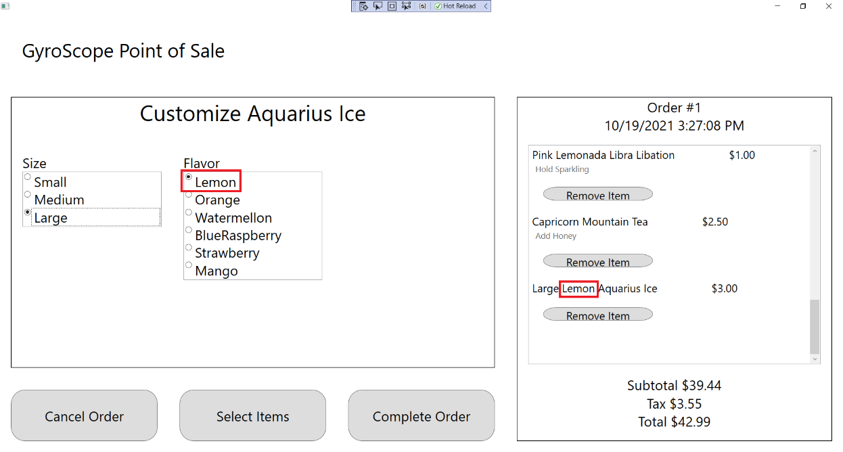

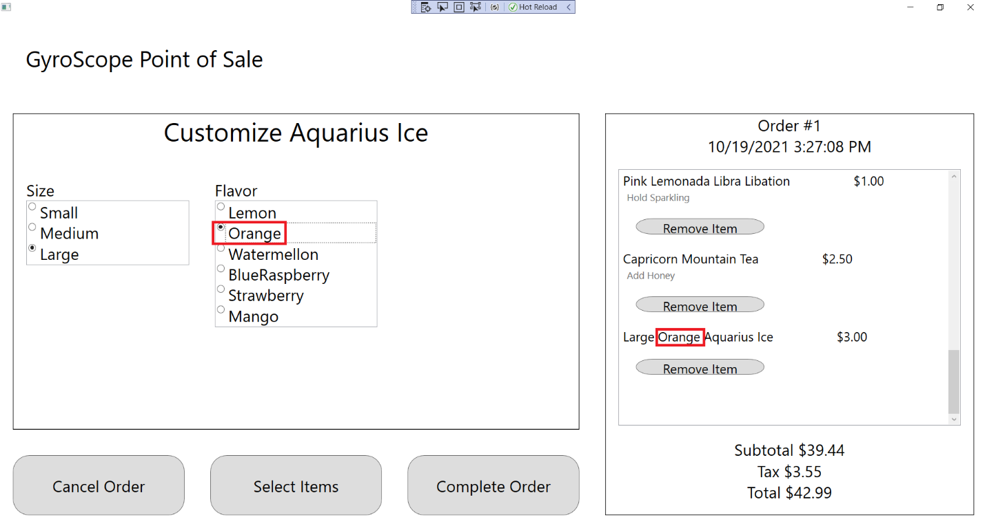

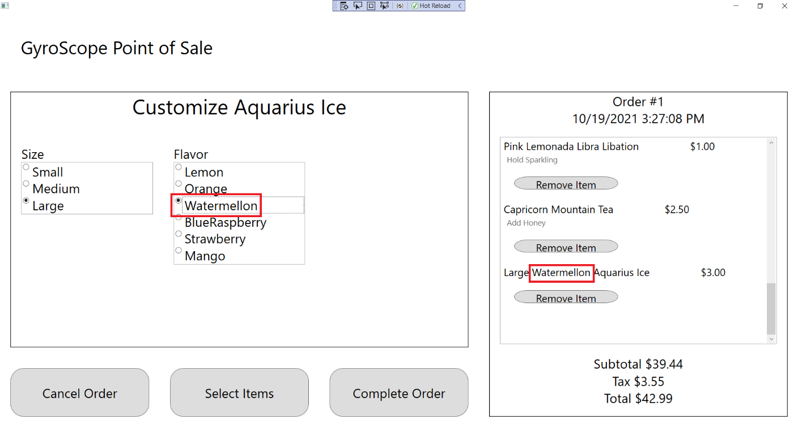

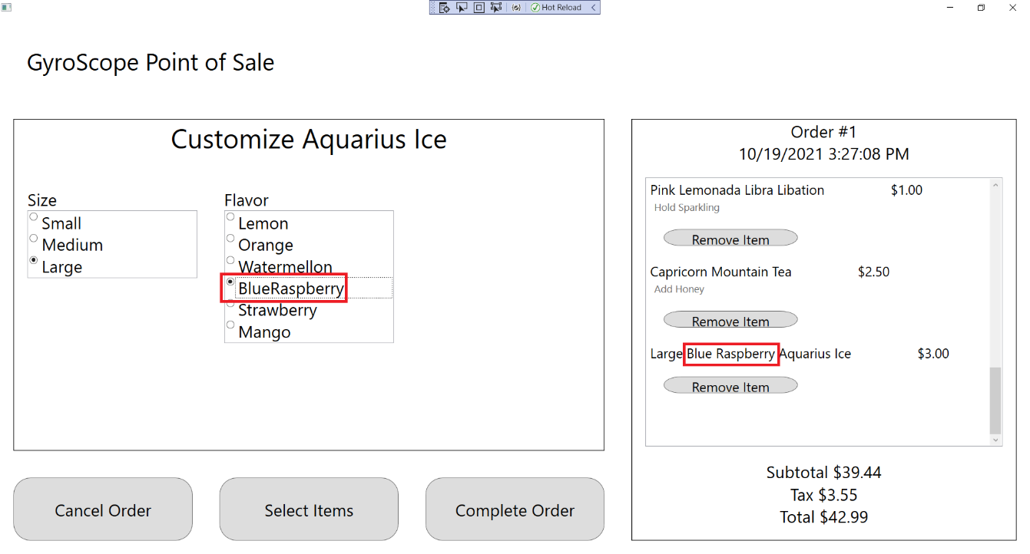

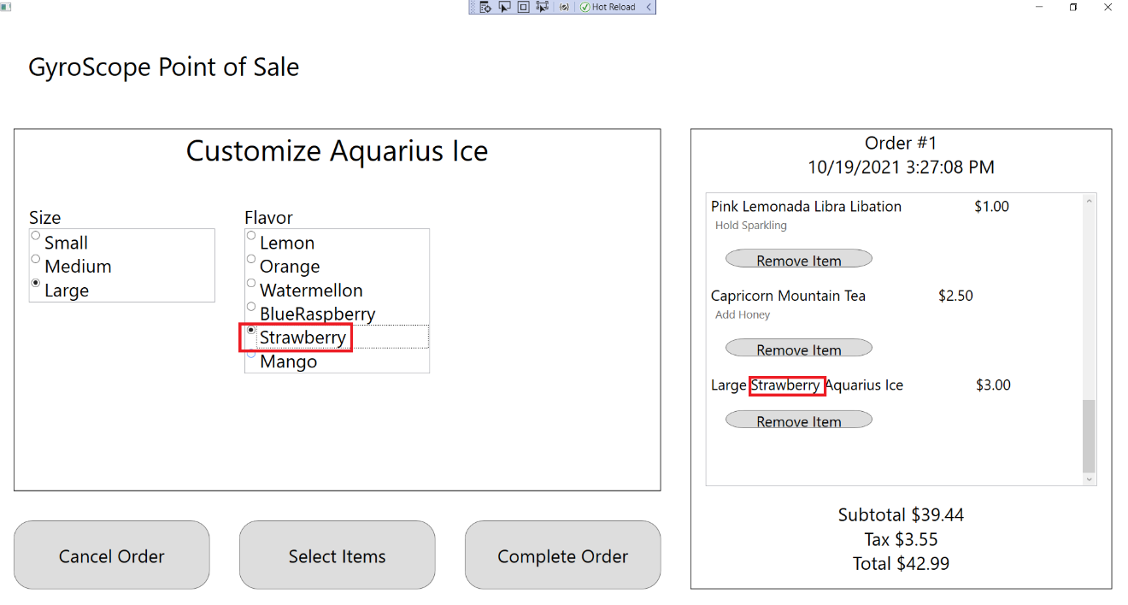

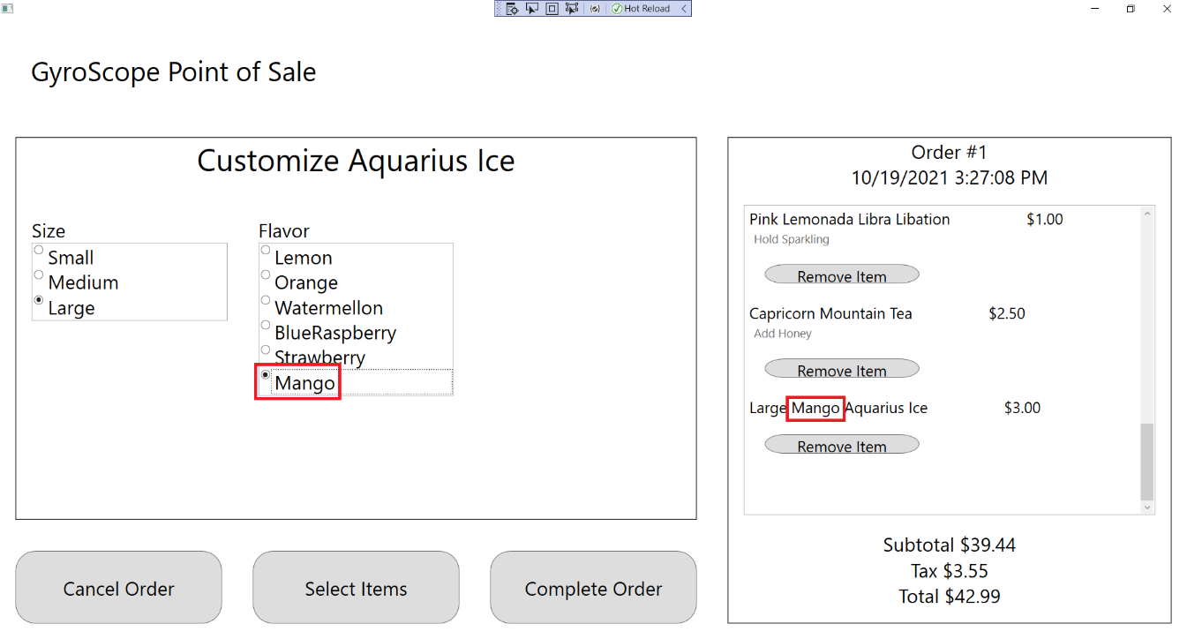

1. Click on the “Select Items” button to return to the Item Selection Menu:

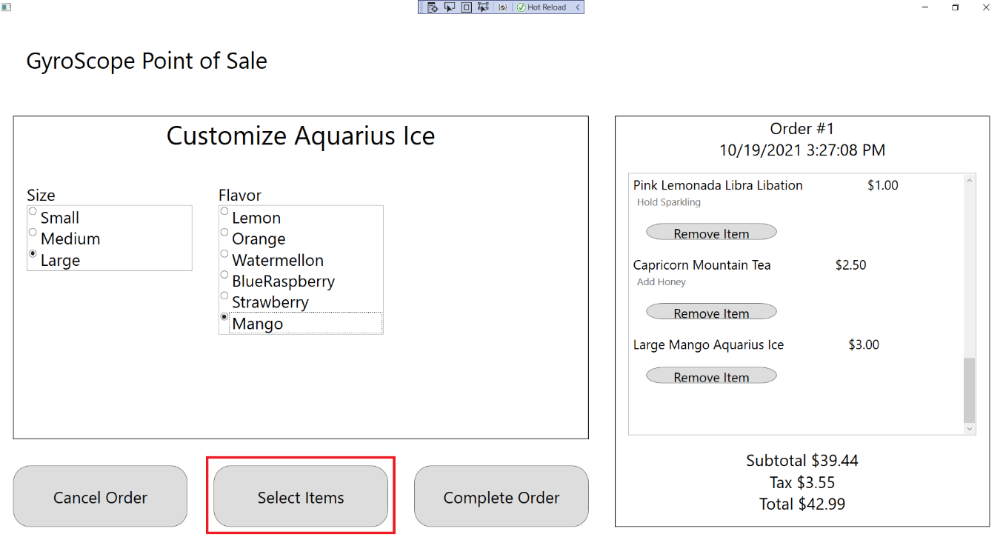

## Test #12 Adding and Customizing CancerHalvaCake

1. Click on Cancer Halva Cake:

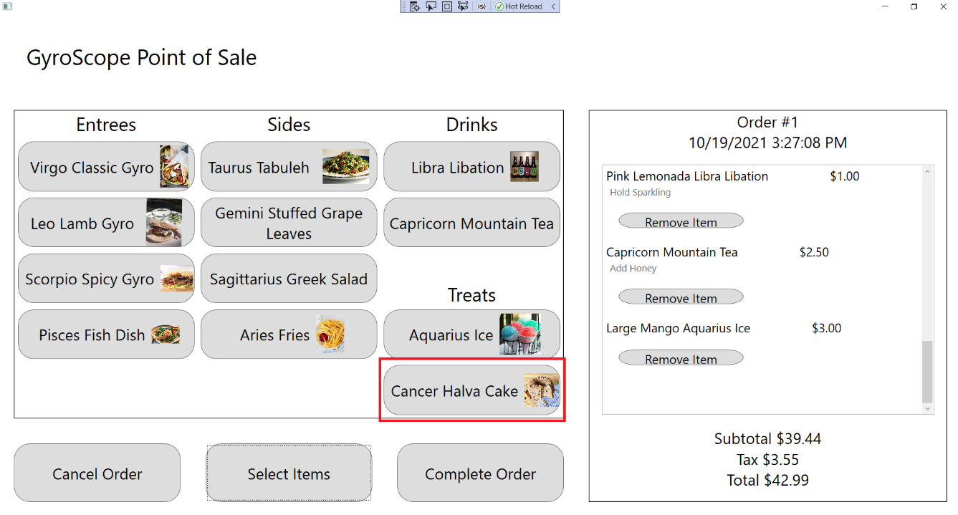

1. The customization screen should appear with a message saying that Cancer Halva Cake cannot be customized. A Cancer Halva Cake should be added to the order, with Order #1, $3.00 Price, $42.44 Subtotal, $3.82 Tax and $46.26 Total being displayed:

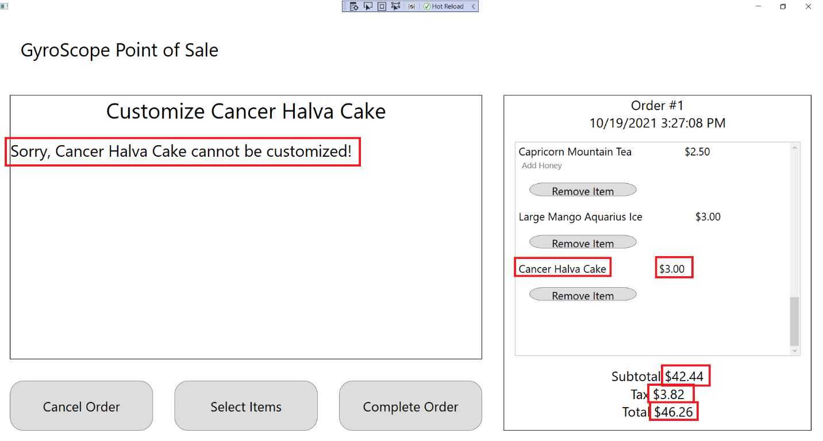

## Test #13 Testing Credit/Debit Card Payment

1. Start the program and add a Capricorn Mountain Tea as shown previously:

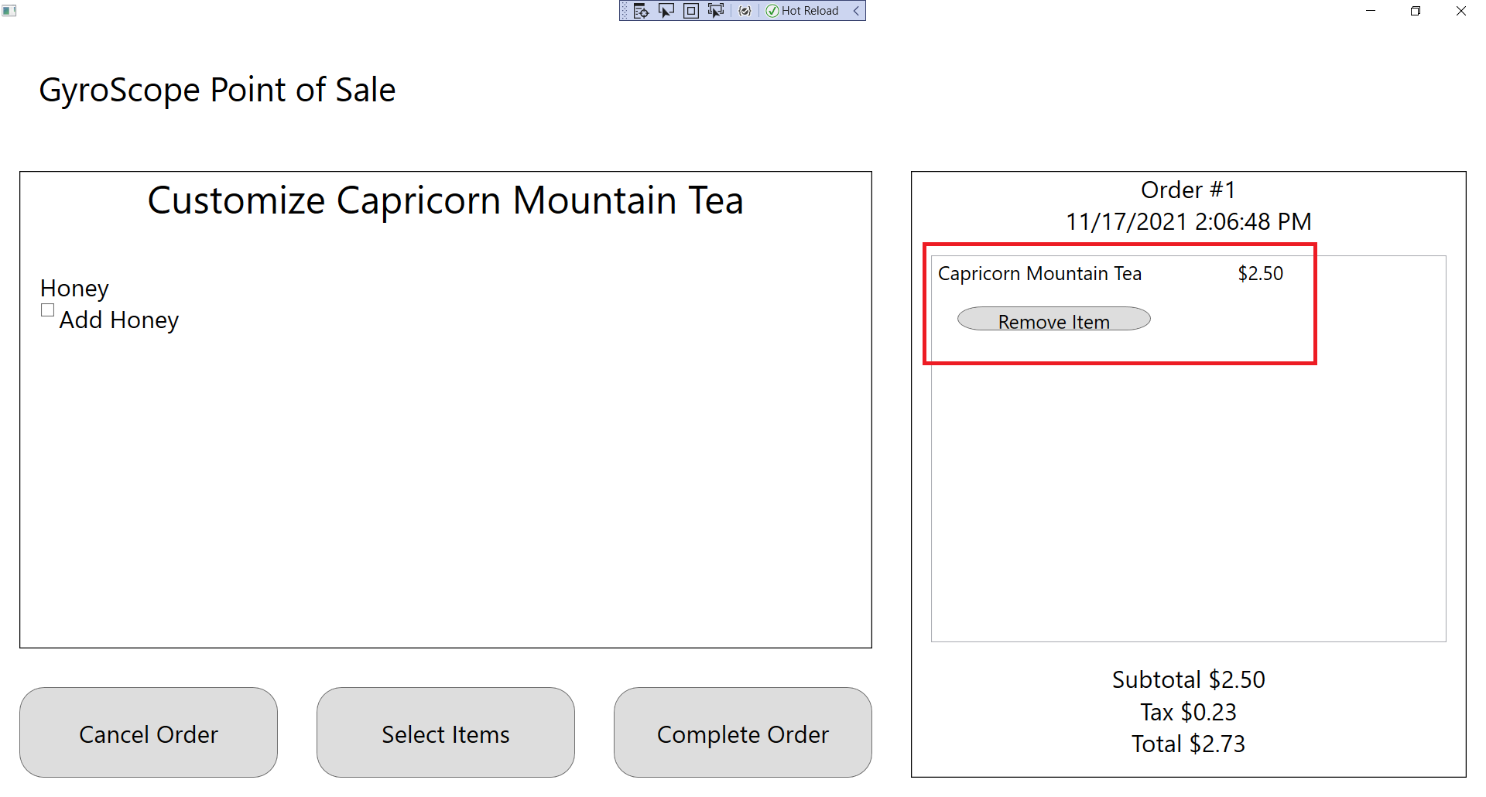

1. Select the “Complete Order” button at the bottom center of the application:

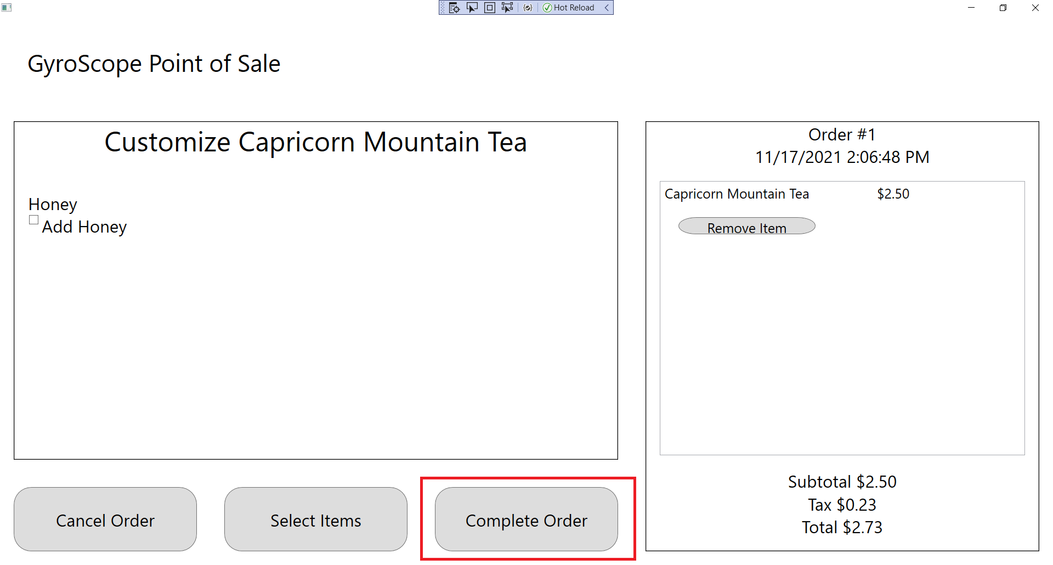

1. A Payment Options screen should appear where the Item Customization screen was. Press the “Credit” or “Debit” buttons. Both have the same functionality in the application and are separate for customer preference:

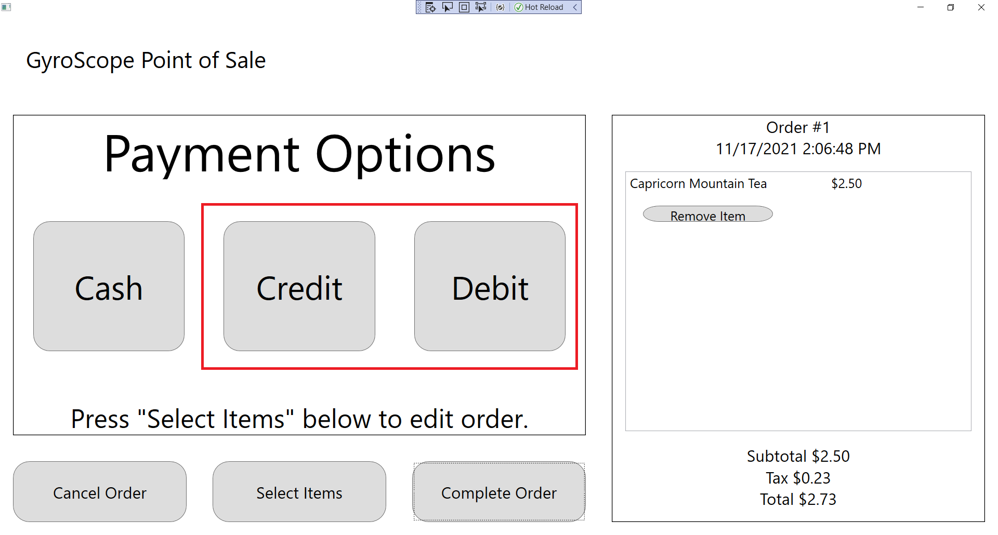

1. Once “Credit” or “Debit” are selected, the customer will be able to swipe their card. If the card is not accepted, a message box should appear explaining the cause of rejection. If the cause is ambiguous, the message box will say, "Card Declined: Please try again or choose a different payment method." If the cause is a read error, the message box will say, "Card Read Error: Please try card again." If the cause is insufficient funds, the message box will say, "Insufficient Funds: Please choose a different payment method." If the cause is incorrect pin, the message box will say, "Incorrect Pin: Please try card again." Press the OK button and press “Debit” or “Credit” to have the customer try again:

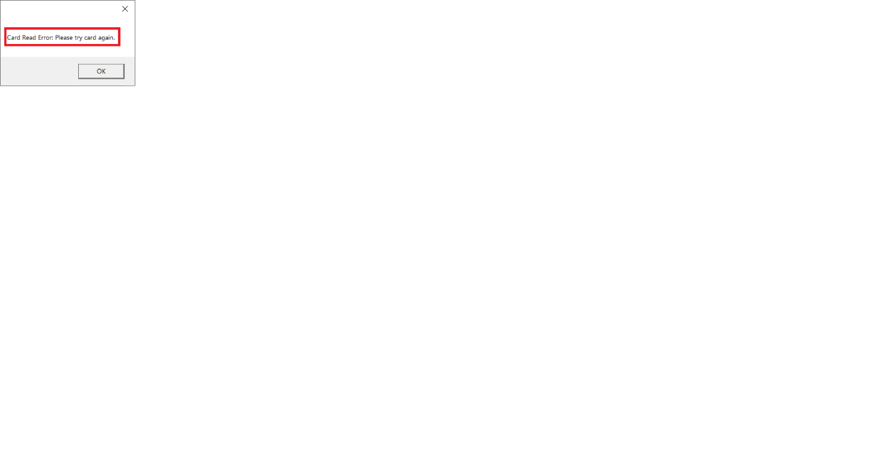

1. Once the customer successfully pays, a receipt will be printed and a new order should be started to prepare for the next customer. The Order label should be incremented by 1. The Subtotal, Tax, and Total labels should be at $0.00:

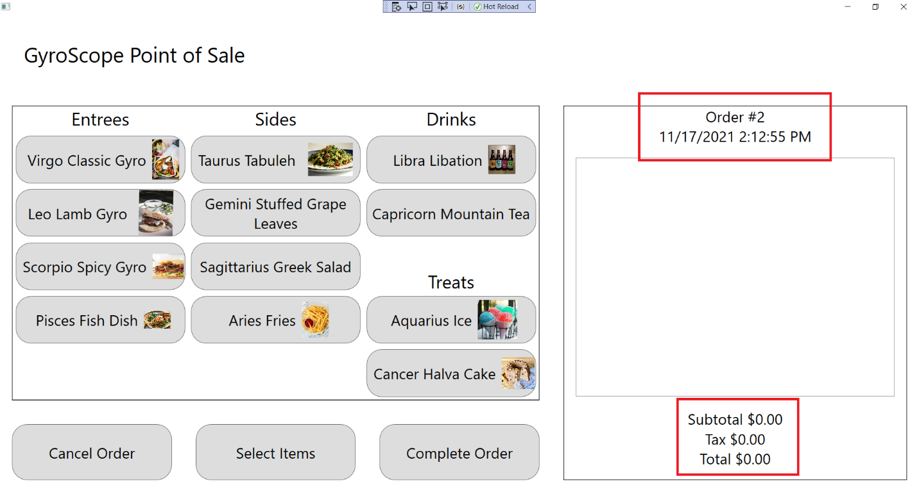

## Test #14 Testing a Cash Payment

1. Add a Large Blue Raspberry Aquarius Ice to the order, as shown previously:

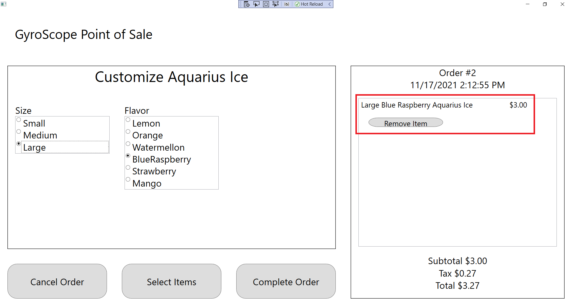

1. Press the “Complete Order” button in the bottom center of the application:

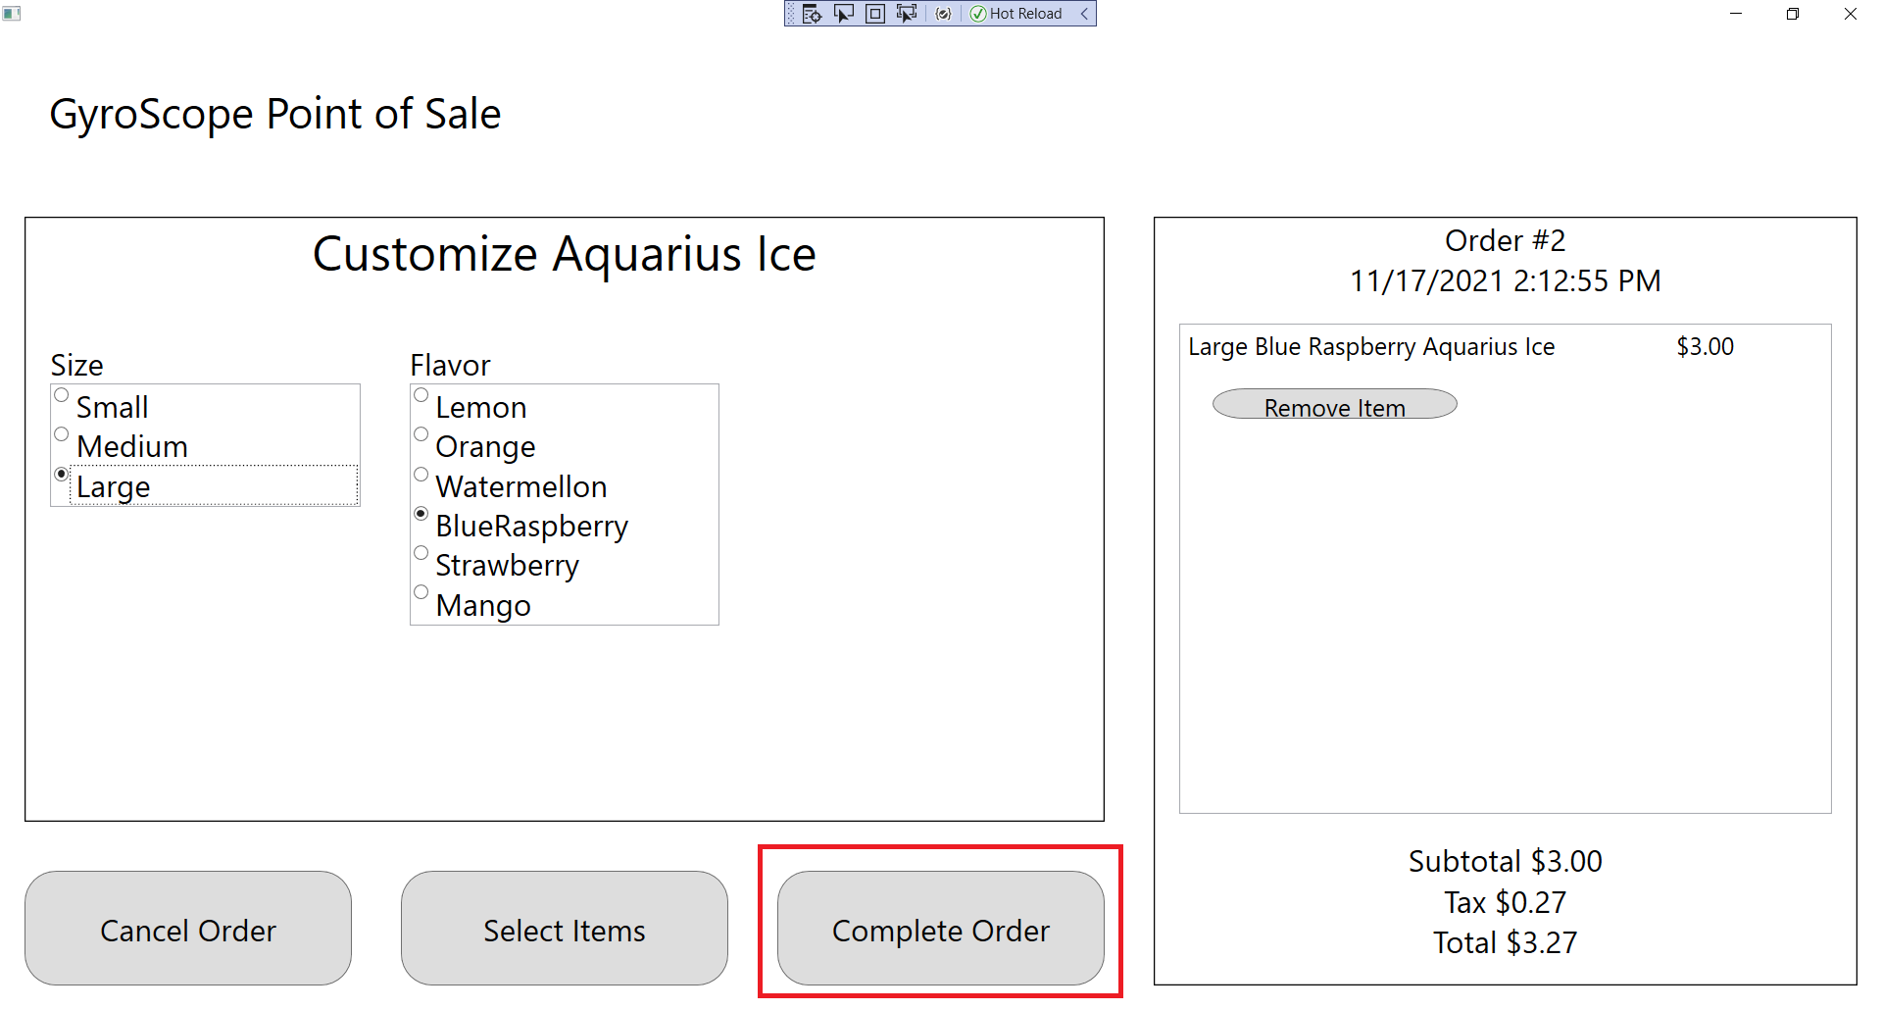

1. A Payment Options screen should appear in place of the Menu Item Customization screen. Select the “Cash” button:

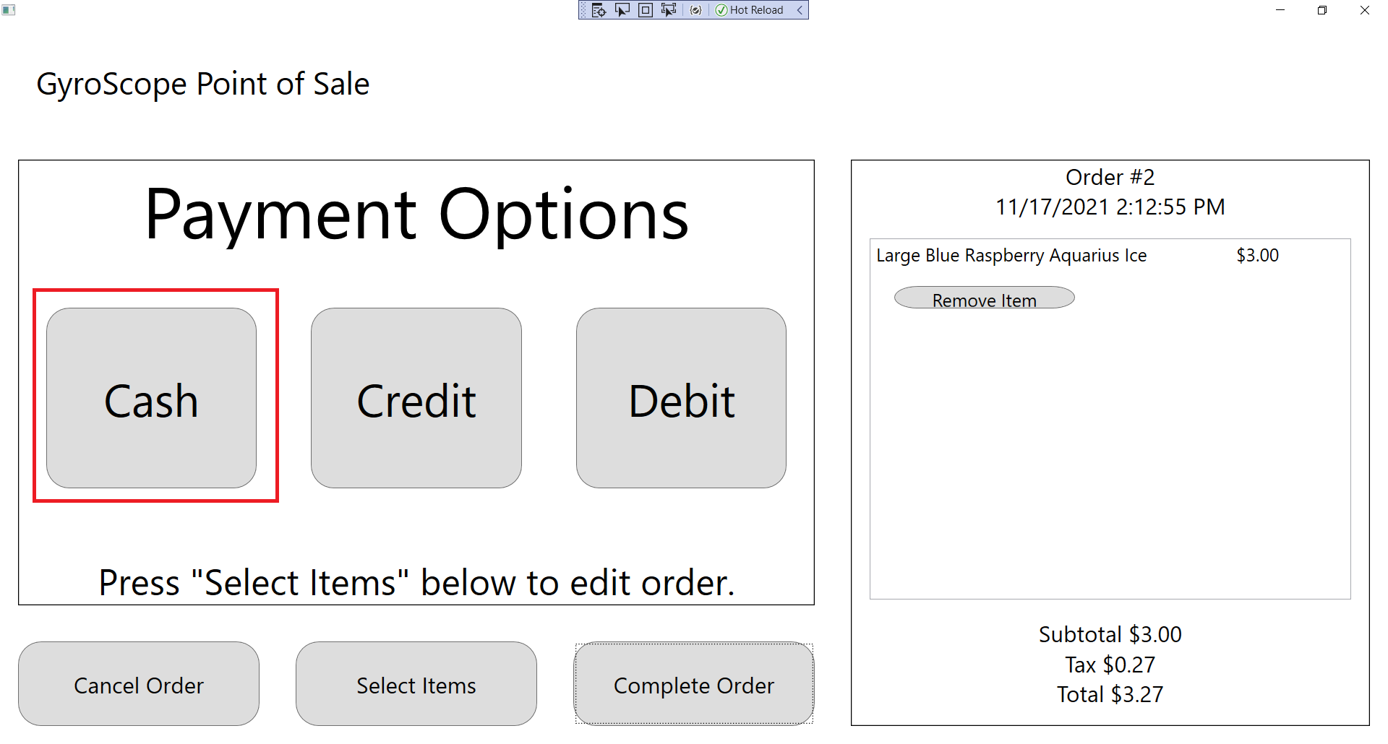

1. The customer has a $50 bill. Add it to their payment using the “+” button labeled “$50”. A 1 should appear in the “From Customer” column. The correct change should be displayed by the “Changed Owed” label at the bottom of the Cash Payment screen. The quantity of each currency that needs to be given to the customer should be displayed. These numbers are based on the available currency in the CashDrawer:

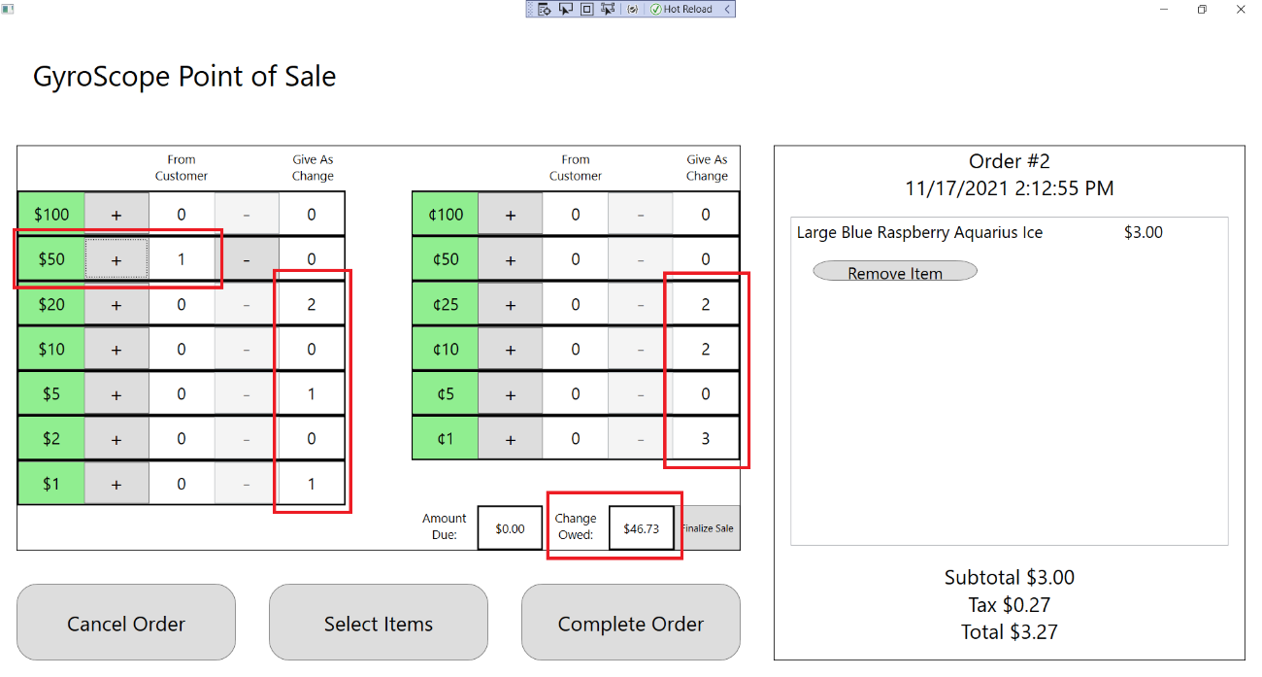

1. The customer decided they don’t want to use a $50 bill. Press the “-“ button next to the $50 label to subtract the bill from the change given:

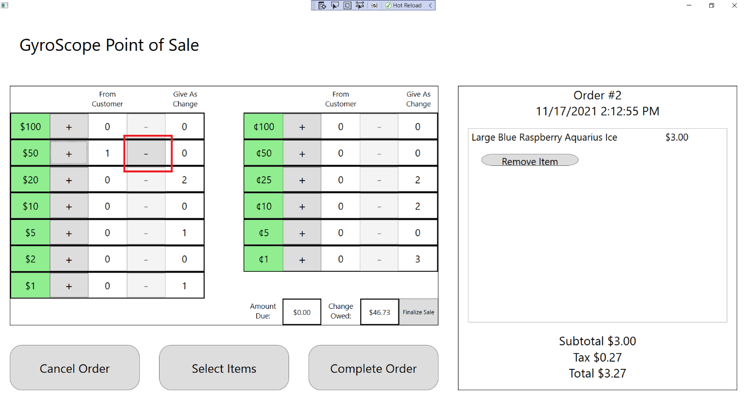

1. Since the customer now owes money to pay their bill again, all quantities of change should be 0. The “Change Owed” section should read $0.00 and the “Amount Due” section should read the amount of money still owed to the cashier ($3.27 in this case):

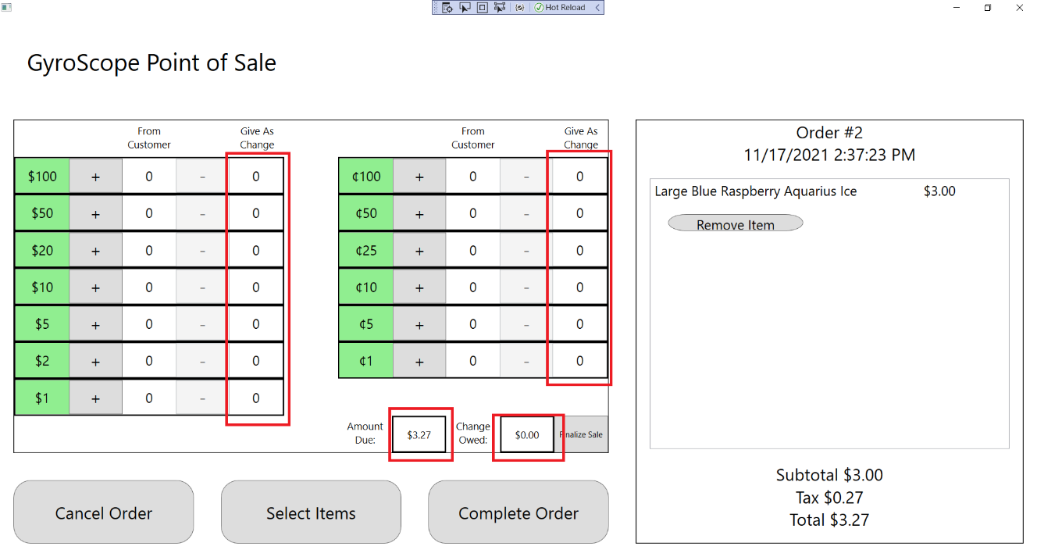

1. The customer decided they actually DID want to use a $50 bill. Add the bill back to the order. Select the “Finalize Sale” button and give the customer their change:

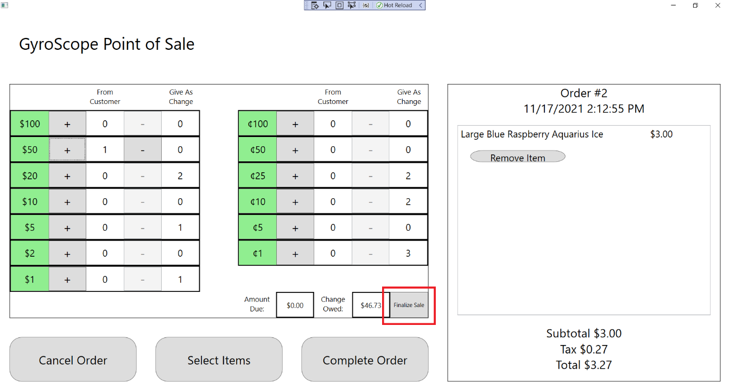

1. A new order should be ready to begin. The Menu Item Selection screen should be displayed. The Order label should be incremented by 1 and the Subtotal, Tax, and Total should all be at $0.00:

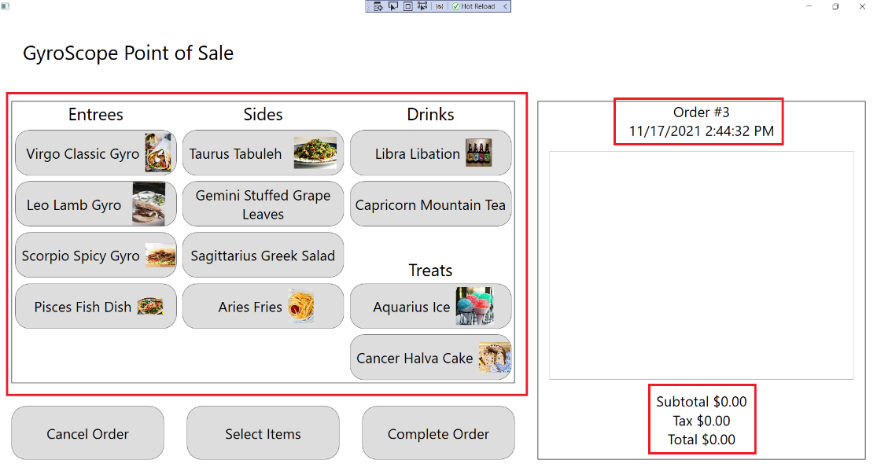

## Test #15 Editing an Order from the Payment screens

1. Add a Large Blue Raspberry Aquarius Ice to the order, as shown previously:



1. Press the “Complete Order” button in the bottom center of the application:



1. A Payment Options screen should appear in place of the Menu Item Customization screen. Select the “Cash” button:

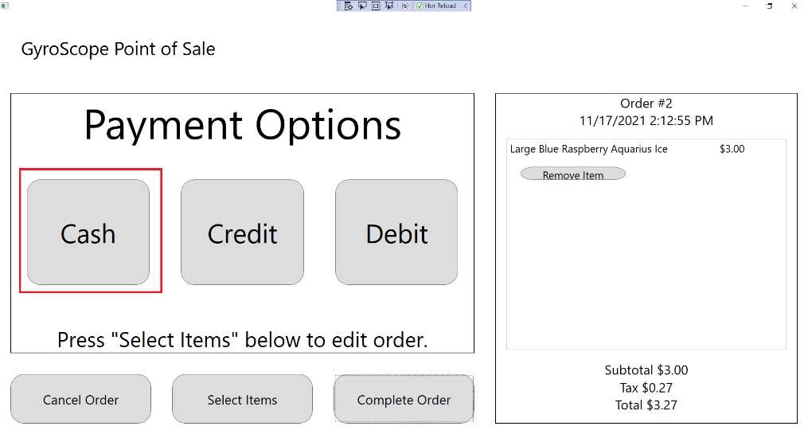

1. The customer has a $50 bill. Add it to their payment using the “+” button labeled “$50”. A 1 should appear in the “From Customer” column. The correct change should be displayed by the “Changed Owed” label at the bottom of the Cash Payment screen. The quantity of each currency that needs to be given to the customer should be displayed. These numbers are based on the available currency in the CashDrawer:

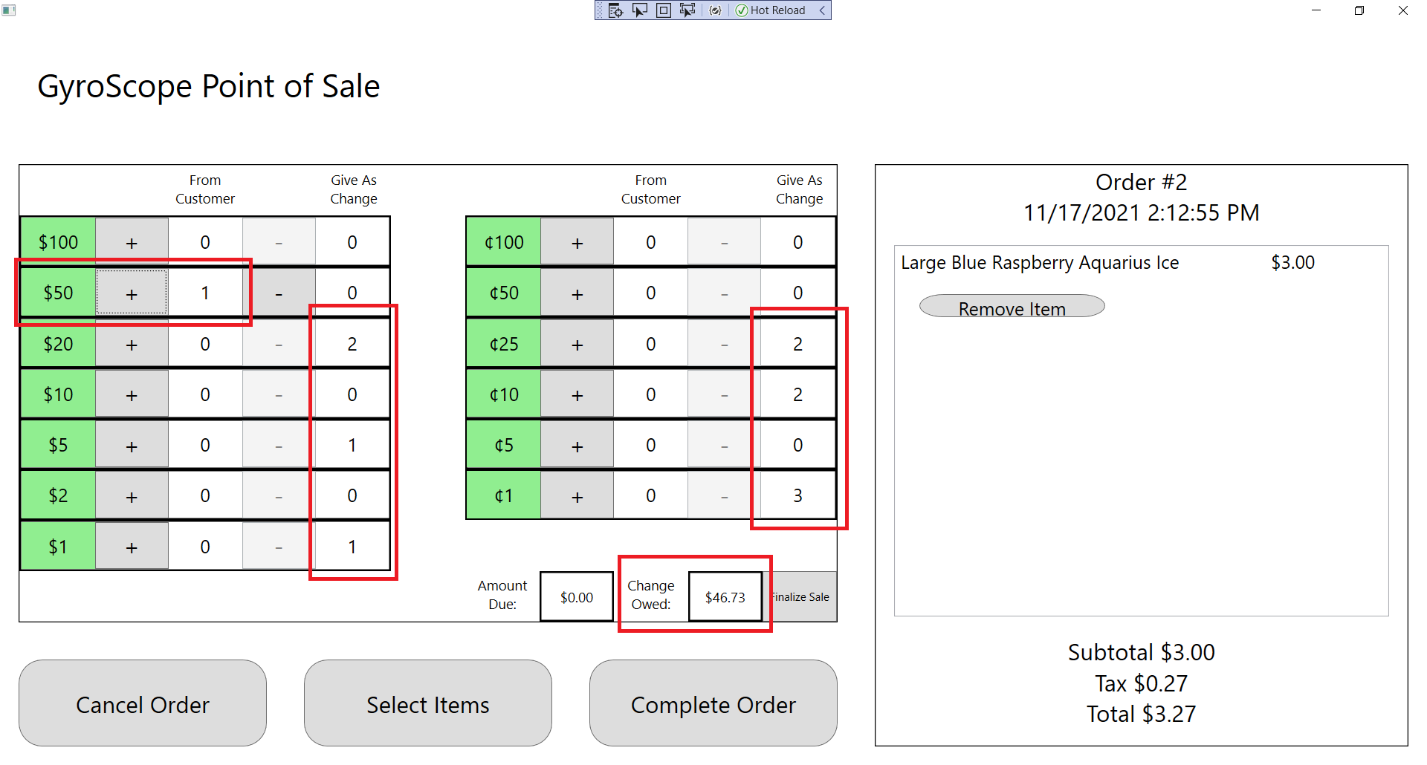

1. Press the “Select Items” button at the bottom of the application:

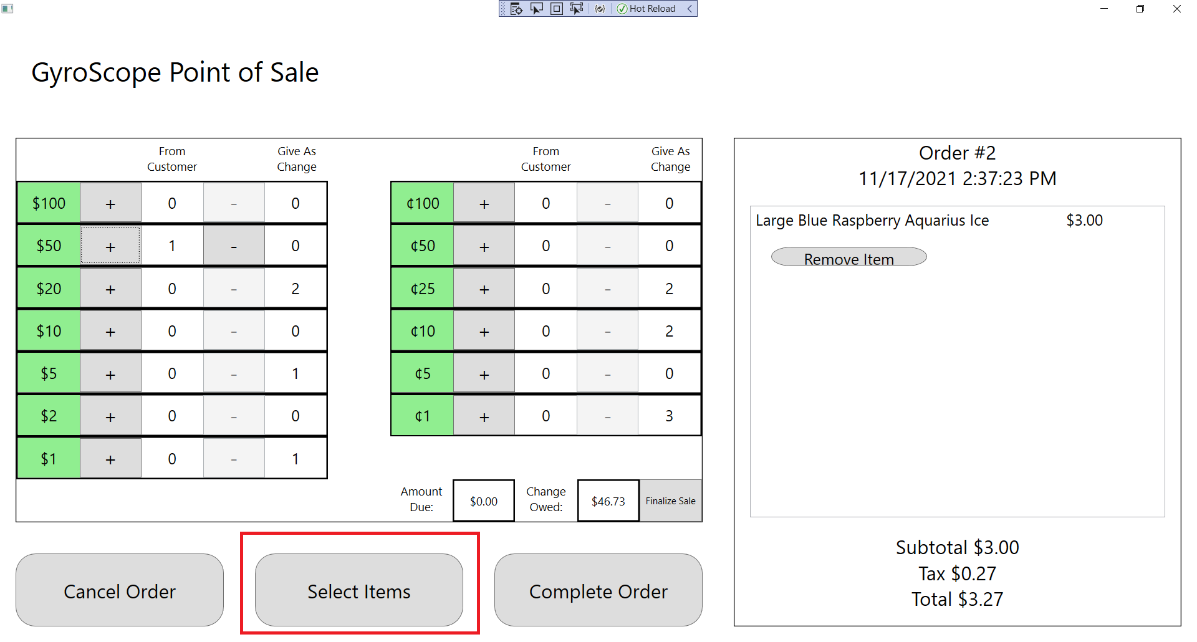

1. The Menu Item Selection screen should appear where the Cash Payment screen was. Add a medium Aries Fries to the order:

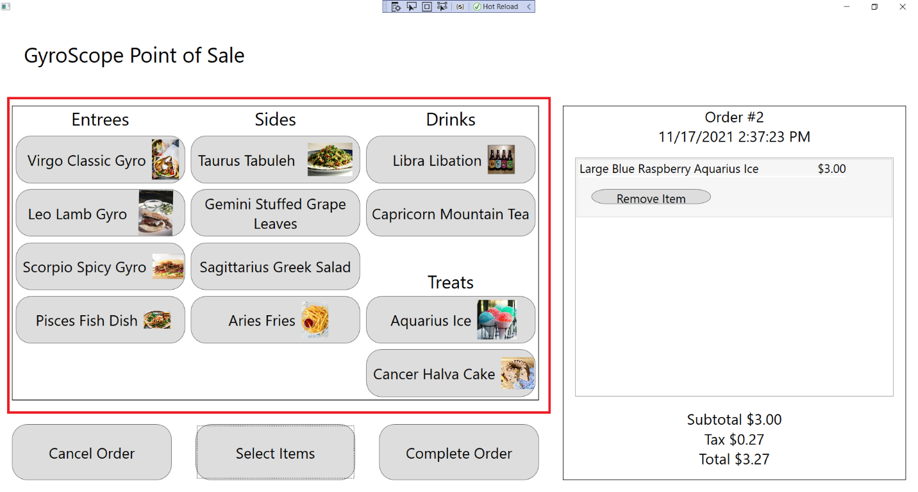

1. The medium Aries Fries should be displayed in the Order Summary panel:

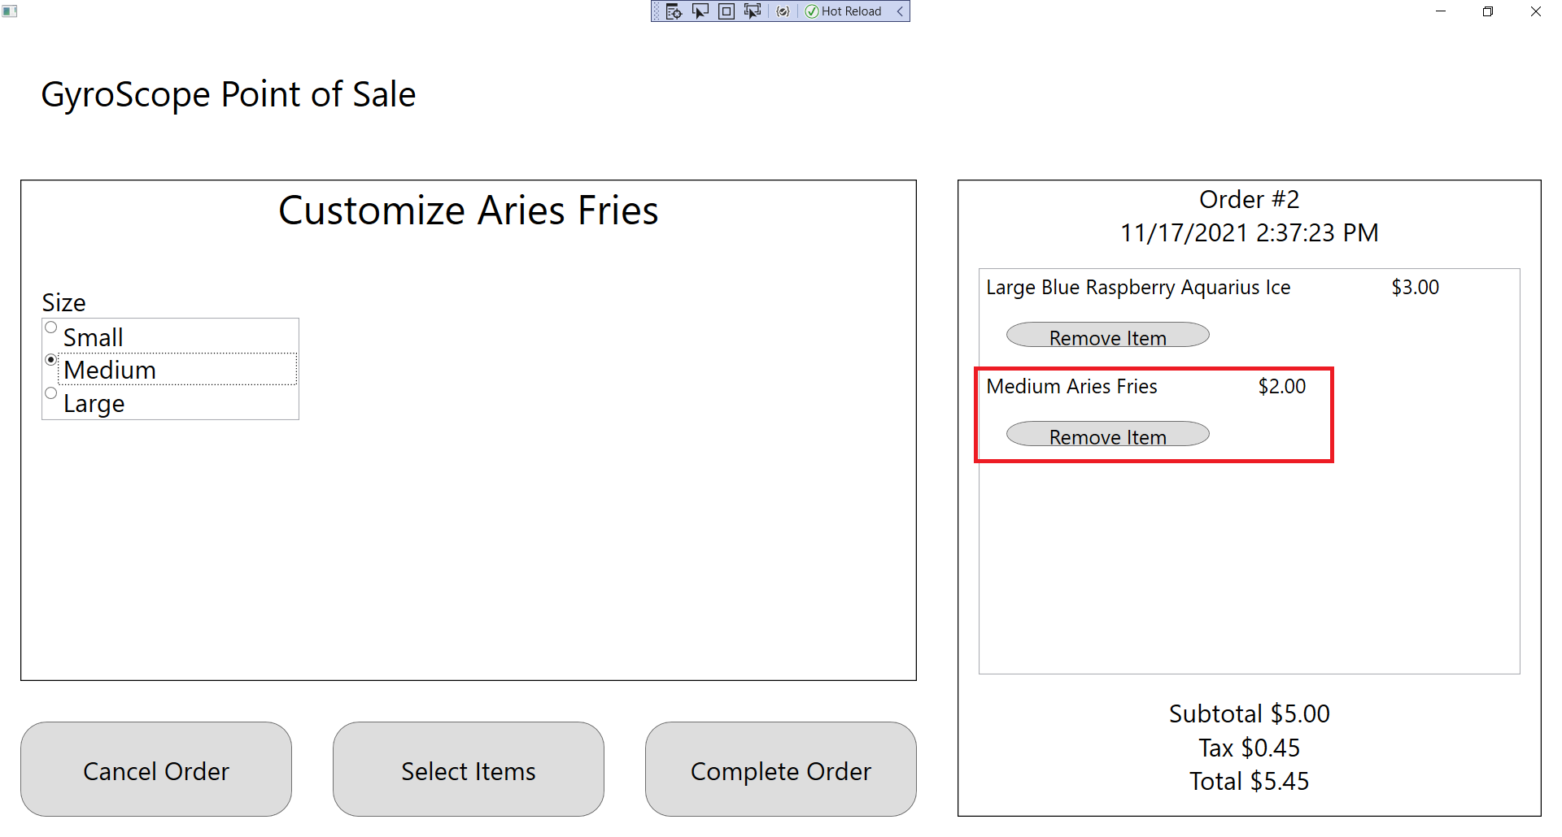

1. Press the “Complete Order” button:

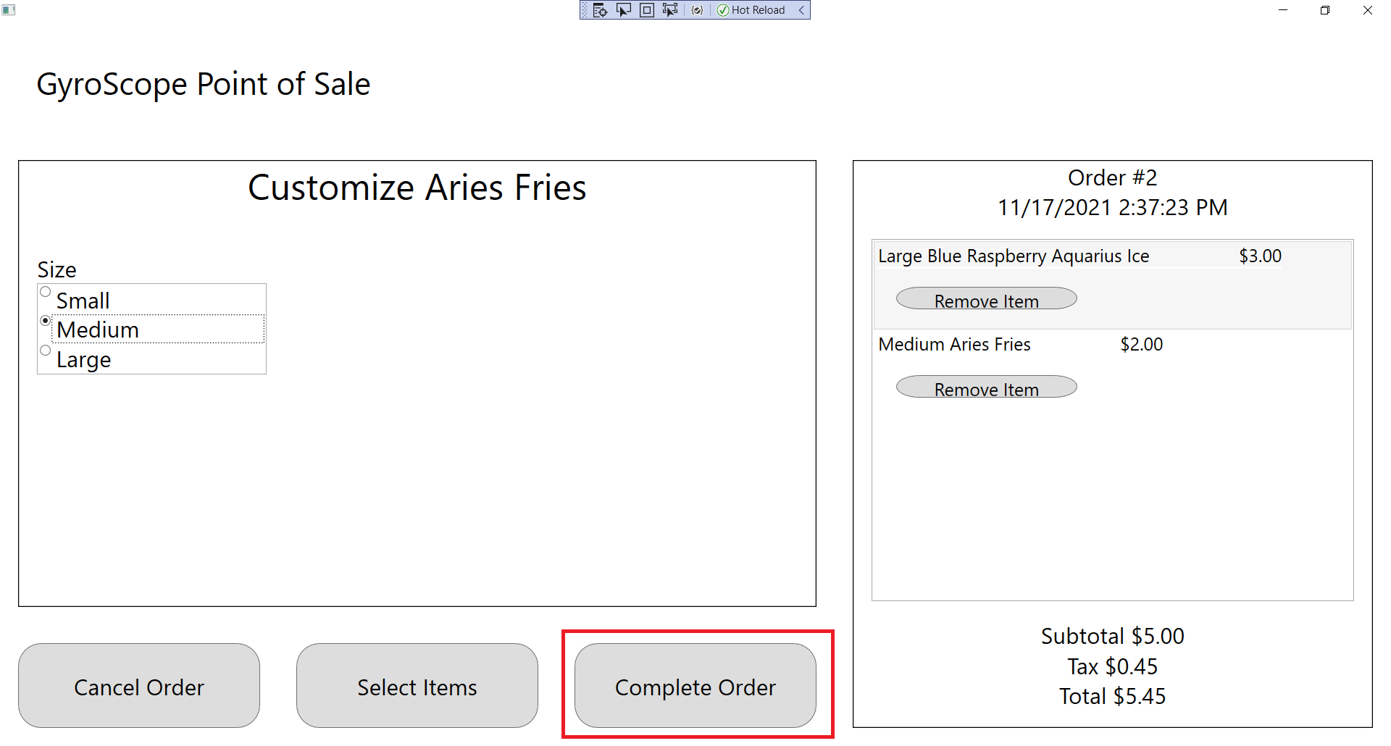

1. The Payment Options screen should appear. Press the “Cash” button:

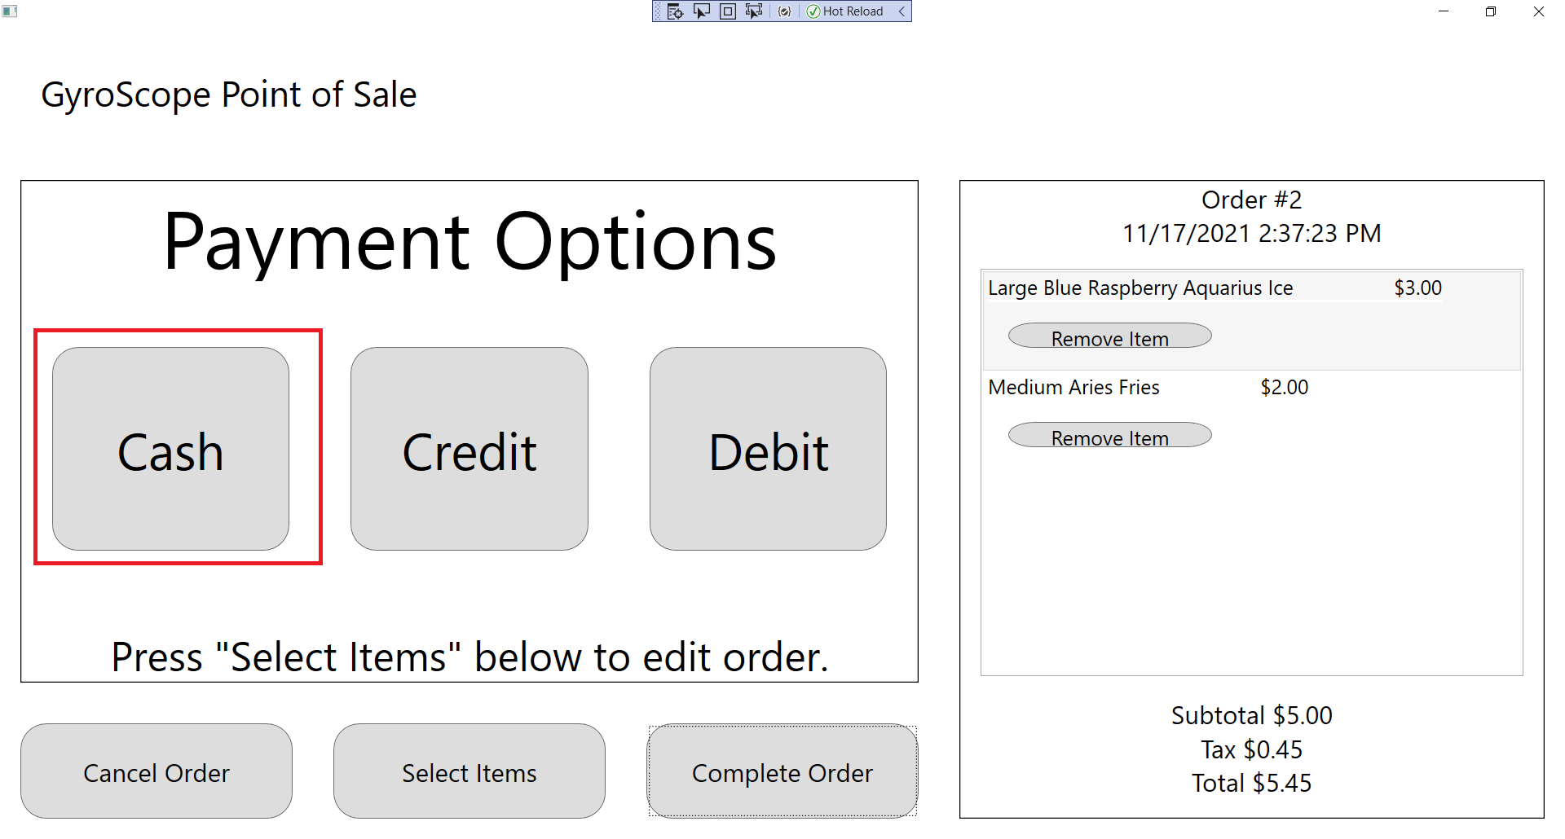

1. Since the CashDrawer is not opened until the transaction is finalized, the customer should have their bills and the “From Customer” quantities should read 0. The amount due should be the total from the order and the change owed should read $0.00. Add the customer’s $50 bill back to the order:

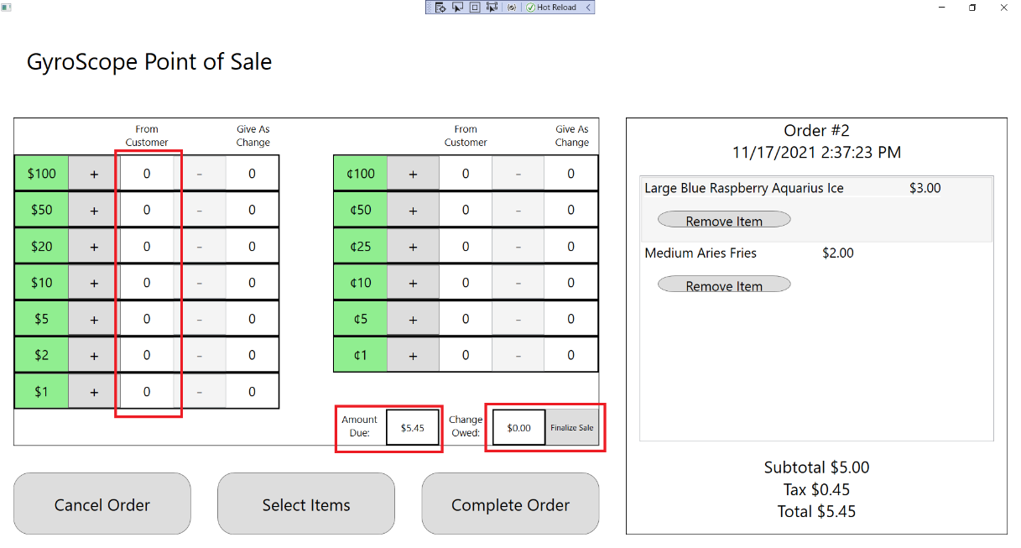

1. The currencies and change should be updated to reflect the addition of a new item to the order:

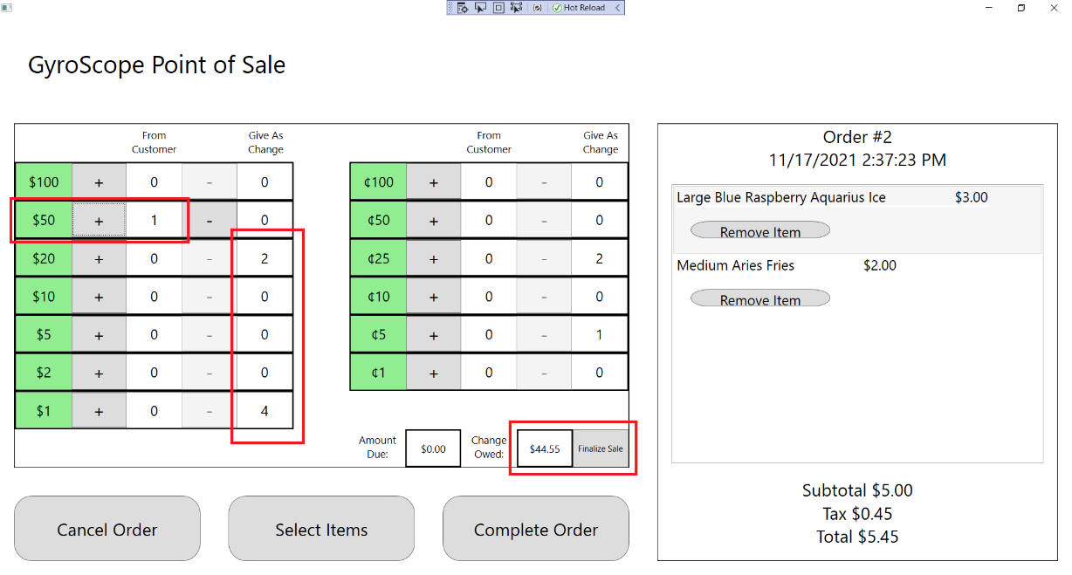

## Test #16 Canceling an Order from Anywhere in the Application

1. Add a Capricorn Mountain Tea to the order as shown previously:

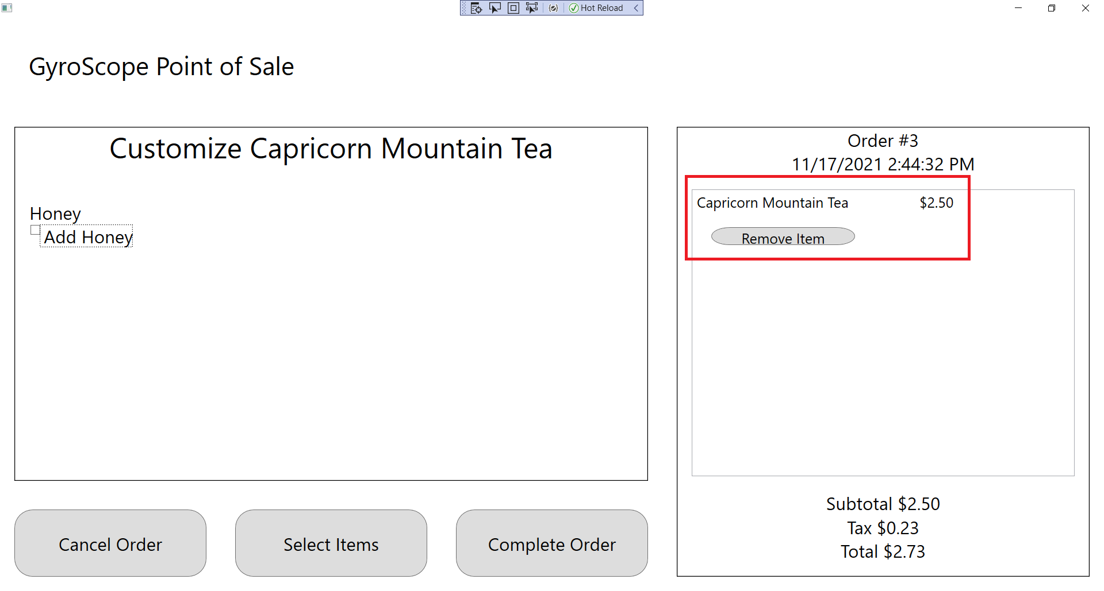

1. Press the “Select Items” button:

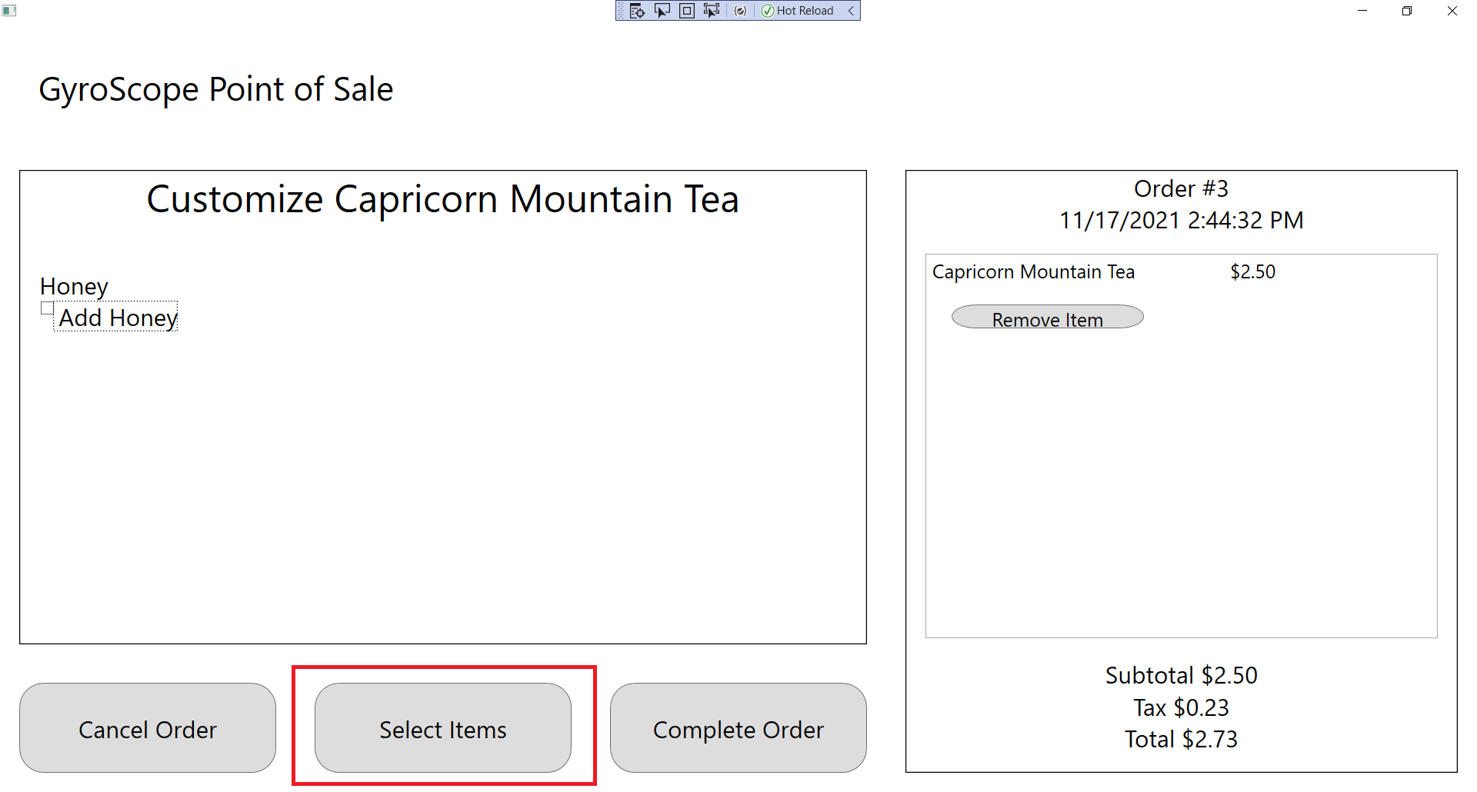

1. Add a Taurus Tabuleh to the order. It should be appropriately displayed in the Order Summary screen:

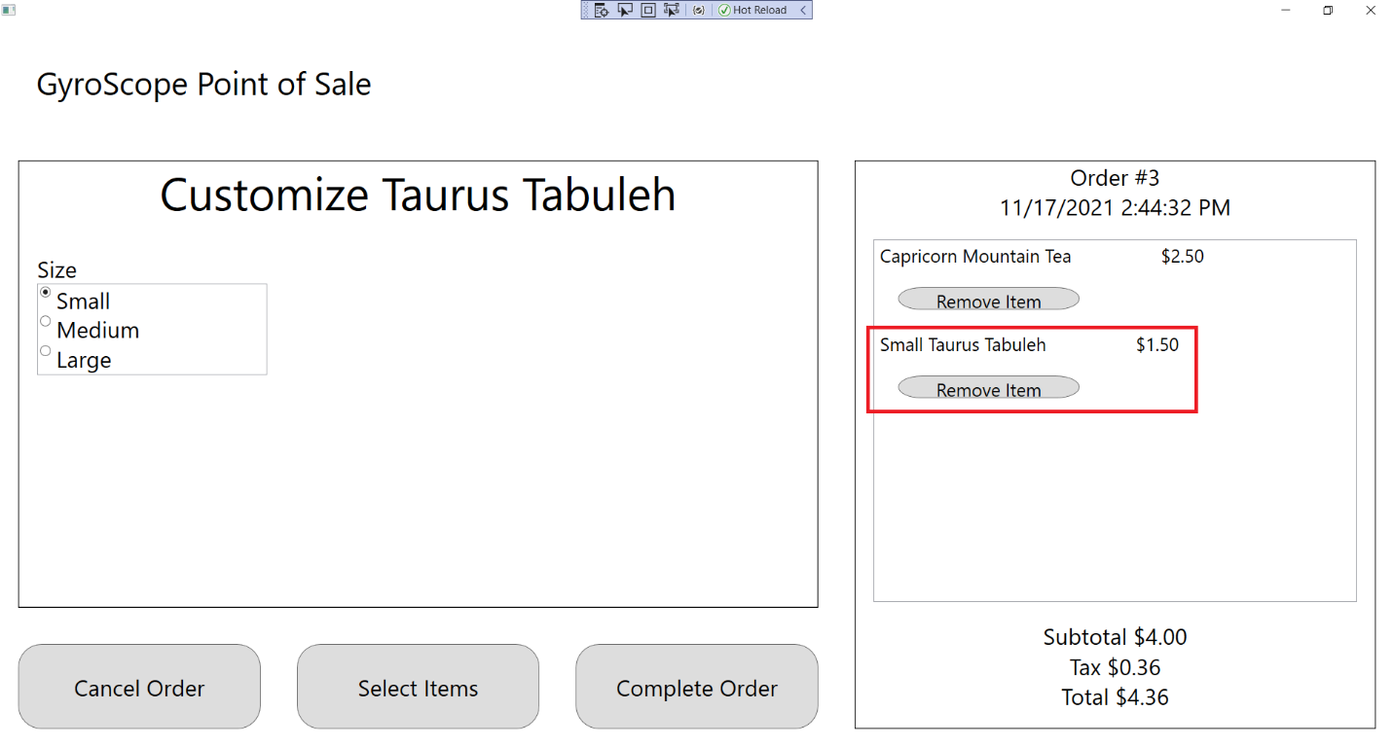

1. Select the “Complete Order” button. It should take you to a Payment Options screen:

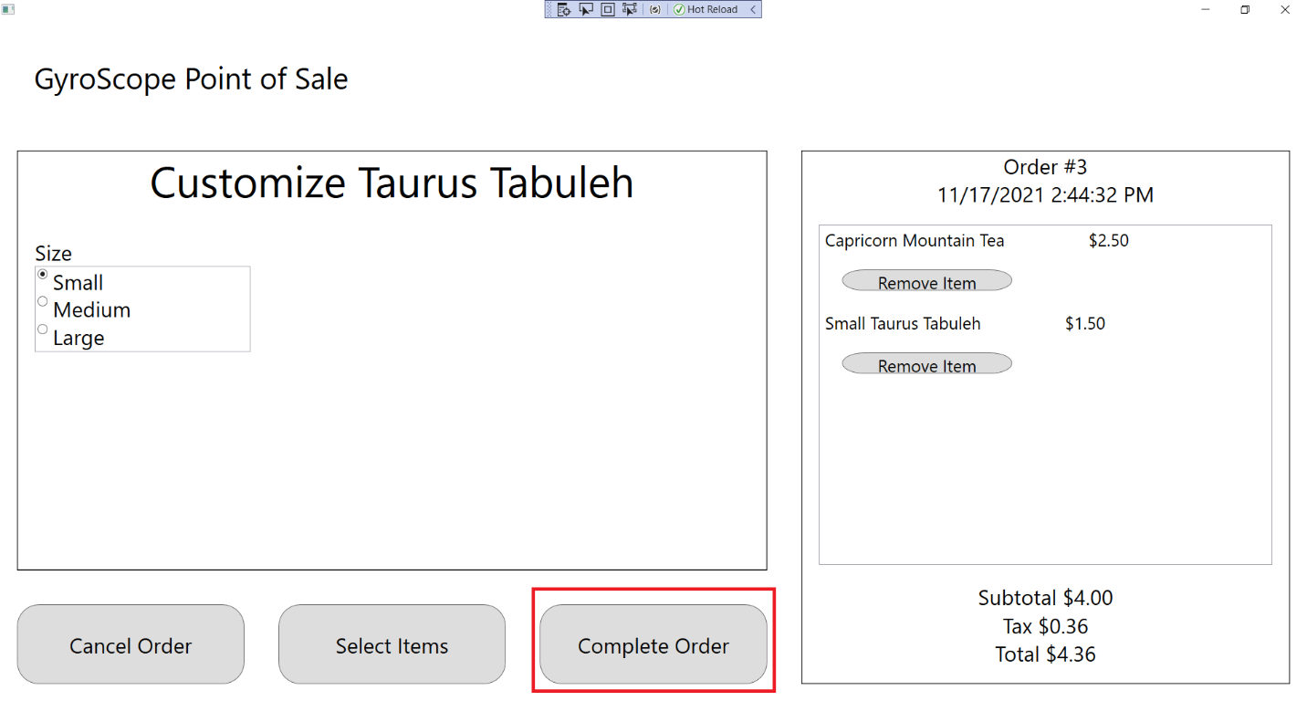

1. Press the “Cancel Order” button in the bottom left corner of the application:

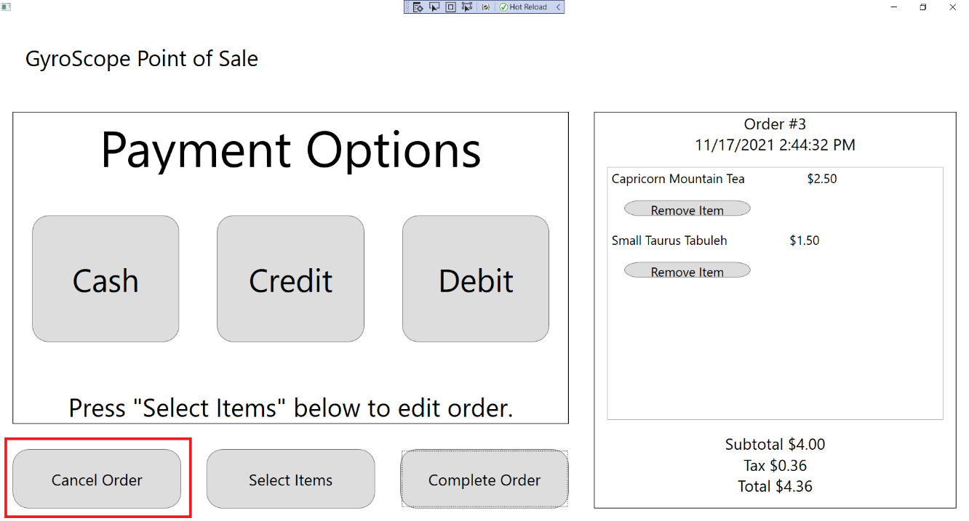

1. The order should be canceled. A new order should be ready for the next customer. The Menu Item Selection screen should be displayed. The Order label should be incremented by 1. The Subtotal, Tax, and Total should all display $0.00:

